Constitutional courts
By Sanaullah Baloch
Tuesday, 23 Feb, 2010
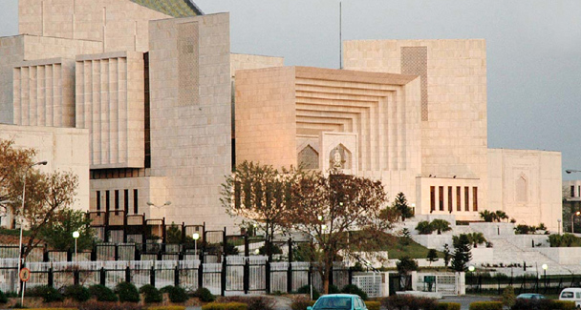
The federal constitutional court must be located far from the orbit of power and have equal representation from the four provinces.

The crisis of the judiciary versus the executive in the NRO case and the judges appointment case as well as the judiciary versus the super-establishment predicament in the missing persons case have once again highlighted Pakistan’s fragile institutional relations.
Although inflexible and barely implemented, Pakistan’s constitution does provide basic guarantees to the rights of individuals and institutions. However, historical accounts and empirical evidence paint a bleak picture in which the superior judiciary has been unable to handle or resolve delicate political, constitutional and conflicting matters regarding the delineation of centre-province relations, resource distribution, the division of power, equal representation, free and fair elections and human rights.
Full-fledged conflicts have resulted at a heavy cost to individuals and institutions. Though the existing judiciary is trying hard to repair its institutional credibility it lacks the capacity and strength to regulate, monitor and prevent a range of institutional and regional conflicts and to protect individual rights.
Although the judiciary took strong and urgent action against the government’s desire and design in the appointment of judges, in matters related to the provinces, people, rights and guarantees it stays well within certain limits. To give an idea of the complexity of the subject one can take the example of the Peshawar High Court which recommended that NWFP legislators take up the issue of gas supply from the province’s own reserves with the National Assembly — despite Article 158 of the constitution. It was further said that nobody could keep the courts from taking note of constitutional violations but that some verdicts could lead to political complications.
Nevertheless, all courts in civilised societies apply constitutional provisions and the law without fear, favour or prejudice. Parliament in Pakistan is no longer a representative institution to rectify existing socio-economic and political imbalances. Dozens of resolutions have been passed by the Balochistan Assembly to no effect while decisions by parliamentary committees to address Balochistan’s longstanding grievances with regard to outstanding liabilities and gas provision have remained ineffective.
In democracies worth their salt such violations are addressed through established institutions like federal constitutional courts. In more than 60 countries constitutional courts play the role of umpire as well as guardians of the rights of institutions and individuals to discourage any adventurism by the state.Understanding the political need for reform in Pakistan’s inflexible state structure, the PPP and PML-N jointly signed the Charter of Democracy in 2006 to reaffirm their commitment to “undiluted democracy” and universally recognised fundamental rights that would include among other things the creation of a cooperative federation where there was no discrimination regarding the federating units, decentralisation and devolution of power, maximum provincial autonomy and the empowerment of the people.
The charter clearly envisioned the establishment of a federal constitutional court to resolve constitutional issues, giving equal representation to each federating unit, members of which could be judges or persons who qualified to be judges of the Supreme Court. The deed redefined the role of the Supreme Court and the high courts and also mentioned that existing courts would hear regular civil and criminal cases.
Had Pakistan had a constitution spelling out the mandate of a constitutional court in conflict resolution, the country would not have been in the political turmoil it faces today. For decades the manner in which constitutional issues have been dealt with has changed the course of history and paved the way for the powerful, and not the legitimate, to rule the country.The absence of unambiguous institutions that can resolve various legal and constitutional disputes and keep a check on government bodies has resulted in the misuse and abuse of authority. Widespread human rights abuses must be seen in a broader perspective where the establishment, civil bureaucracy and the law-enforcement and security agencies have remained above legal and judicial accountability.
Citizens from marginalised provinces such as Balochistan, Sindh and the NWFP hardly approach the apex courts for any political and social remedies, as the superior judiciary has often been seen to provide legitimacy to the extra constitutional acts of our rulers.
International experience indicates that federal constitutional courts are an essential component of a smoothly run democratic political system. As the custodian of basic law, the constitutional court could play a significant role in umpiring the federal system, resolving conflicts among various branches of the government, overseeing the process of parliamentary democracy, monitoring political parties and reviewing restrictions on basic rights and liberties.
Constitutional courts or their equivalent operate in 62 countries to resolve conflicts among the various government branches. They oversee the process of parliamentary democracy and review restrictions on fundamental rights. These courts are not an integral part of the regular judicial system, but installed as a separate judicial institution.
A constitutional court is regarded as the highest court when it comes to the interpretation, protection and enforcement of the constitution. The German, French, Spanish and Italian constitutional courts have played a pivotal role in reducing and preventing institutional conflicts and in promoting a cooperative federal system. The role of a constitutional court in Italy includes monitoring and addressing economic and social discrimination. The one in Spain is the supreme interpreter of the constitution. Such a court has the power to safeguard all fundamental rights.
South Africa’s constitution delegates exclusive jurisdiction to the constitutional court in deciding disputes about powers and the constitutional status of branches of the government. This court is also empowered to decide the legitimacy of any amendment to the constitution. Meanwhile, the German federal constitutional court, a widely respected institution in the country, is located in the city of Karlsruhe intentionally to avoid the political, social and institutional influence of the executive.
Pakistanis need effective institutions to regulate, mediate between, prevent and resolve the many unfolding political and constitutional crises. The federal constitutional court is a key element of any working democracy and must be located far from the orbit of power and have equal representation from the four provinces. It should be endorsed by the provincial assemblies to protect human, social, economic and political rights.

