The last of Nepal’s Dura speakers
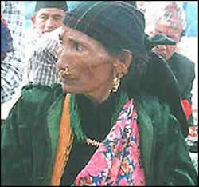
By Charles Haviland
Some scholars are striving to preserve Dura. 1,500 words and 250 sentences have been compiled from the language
PLANS are being made to extend medical help to an octogenarian woman in Nepal who is the last known speaker of a minority language.
None of the rest of Soma Devi Dura’s family speak Dura, despite being from the same ethnic group. The only other person who could speak the language died last August. Now Soma Devi Dura’s health is ailing at her home in the hills of western Nepal, and she has severely impaired sight and hearing.
Surprises: But the 82-year-old is a rich source of songs and folklore in the Dura tongue. In order to communicate with her husband, children and grandchildren she has to use other languages, because she is now believed to be the only surviving speaker of Dura, which belongs to the Tibeto-Burman language family.
Languages decline like this when parents fail to pass them down or children lose interest in them. But some scholars are striving to preserve Dura. Kedar Nagila, who as a child played with Dura children who had already lost their language, has compiled 1,500 words and 250 sentences. He wants to take Soma Devi to Kathmandu for medical treatment, and to interest Dura children in taking lessons in the language.
‘Amazingly fluent’: Nepal has more than 100 tongues, several with fewer than 100 speakers each. Research can throw up surprises. Recently the three recorded speakers of another language, Kusunda, all died or disappeared. But campaigners for indigenous rights went to western Nepal and found a mother and daughter speaking it, and an isolated woman in a different district.
They were brought together, and the woman was able to converse in Kusunda for the first time since 1940, when she was 10 years old. Linguistics Professor Madhav Prasad Pokharel said she was “amazingly fluent”. Although he has been inspired by the revival of Hebrew as a spoken language, he admits that reviving these tiny Nepalese languages is unlikely. But he argues fervently that they can and should be preserved and taught. courtesy bbc news

