Federal govt ignoring ‘saint’ Ali Mardan’s tomb
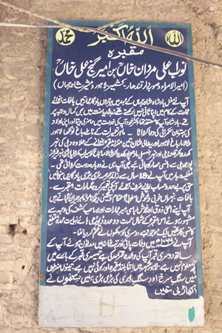
* Official says restoration work to start next week
* Only Rs 28,000 allocated in 2006-07
By Hina Farooq
Photos by Abid Nawaz
LAHORE: The government has been neglecting Ali Mardan’s tomb for several years despite its popularity among the locals, Daily Times has learnt.
The tomb is fast running down. Ali Mardan was a governor of Lahore and Kandahar. The tomb, however, is now turning into a ‘religious’ place where people come to pray. Officials said no amount had been allocated for 15 years to preserve this monument.
Archaeology Department’s Northern Circle director Dr Muhammad Arif said the federal Archaeology Department had earmarked Rs 28,000 for restoring this monument in the 2006-07 Annual Development Plan.
He said the monument remained close as some visitors to the tomb had started extra-religious and anti-social activities.
Arif said the restoration work would start next week. He said the monument would not be handed over to the Punjab Archeology Department (PAD). He said wire gauze would be installed to keep bats off. Also various sprays had been approved by the department in this regard. He said the monument required more than Rs 100 million for its complete restoration.
The tomb is situated inside the Mughalpura railway workshops and is virtually invisible from the road. Only a narrow passage leading to it is visible from the main road. The tomb’s fresco, marble and brickwork have also been worn down.
Many people now believe that Ali Mardan was a saint and visit his tomb to light ritual candles and clay lamps.
Adjacent to Mardan’s tomb, is the tomb of Hamid Shah, a sufi who reportedly spent his life spreading Islam. Drug addicts and scavengers too now gather here. The tomb is now closed on weekdays, opening only on Thursdays. An informal caretaker at the tomb who has been here for the past 35 years telling people about Mardan’s piousness. He distributes biscuits and sweet rice as tabarruk. Mardan’s tomb comes under the Antiquity Act, 1975 and is “protected” by the federal government. The monument’s two domes have blackened and faded by rains. All four minarets and its entrance have vanished. These had some traditional frescos is now inhabited by bats. The tomb is situated in the other building. The monument is now surrounded with bushes and heaps of garbage.

