* 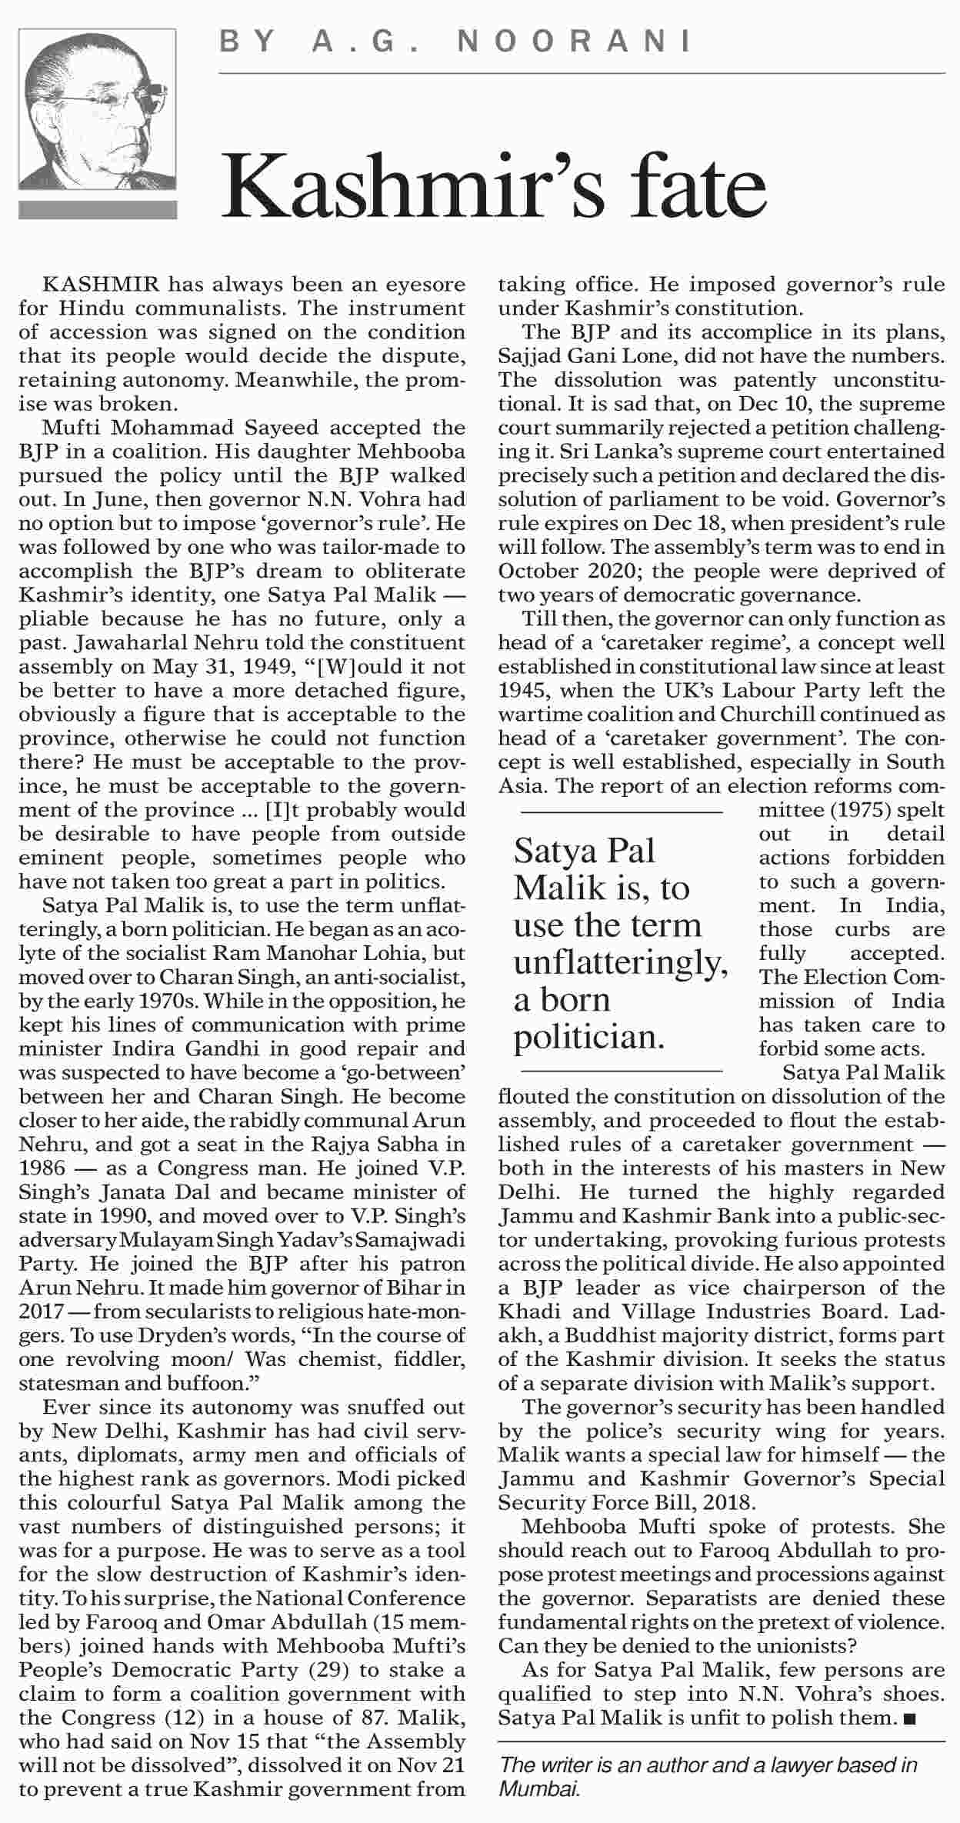Saturday 15th December 2018

|  |  |
| --- | --- |
|  |  |