Violence in Karachi
By Huma Yusuf
Sunday, 10 Jan, 2010
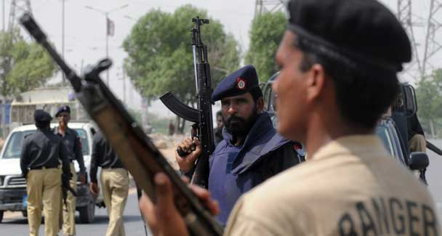
Rather than work towards tearing apart the different types of violence and addressing each systematically and comprehensively, the authorities are operating in a muddle.
Interior Minister Rehman Malik stated on Friday that there are no similarities between the situation in Karachi and Swat. This statement of the obvious is in some ways the best response by the authorities to the recent spate of violence in Karachi.
Acknowledging that the dynamics of violence are locally defined and steeped in histories and circumstances particular to certain places and events is the first step towards effectively maintaining peace and stability.
Karachi has a long history of ethnic conflict, sectarian violence, land mafias and intra- and inter-party tensions. All these have been in play during this past fortnight, making it abundantly clear that a discerning approach to Karachi’s violence is required. Policing and investigations into recent incidents must be informed by knowledge of ‘local’ social, political and economic factors, which in this city of 18 million differ from locality to locality. For that reason, the MQM’s request for the Rangers, the army and intelligence agencies to maintain law and order in the city are akin to slapping a band-aid on a deep, infected wound.
Violent incidents since the last week of December have confirmed that Karachi is facing a hydra-headed threat. Rather than work towards tearing apart the different types of violence and addressing each systematically and comprehensively, the authorities are operating in a muddle.
The Ashura blast which had apparently been claimed by the Taliban was denied by the latter. On Friday, Malik linked Jaish-i-Mohammad, Lashkar-i-Jhangvi (LJ) and Jundullah with that attack. Earlier in the week, an FIA report had claimed that a new militant group was responsible for the blast. Even as it became clear that the Taliban may not have been involved in the Ashura attack, US ambassador Anne Patterson announced a grant of Rs1bn for affected traders, all the while decrying the Talibanisation of Pakistan.
A similar confusion prevails regarding the actors and reasons behind the killings of several people in the last few days. Political parties in Karachi have been asking the Sindh government to intervene and prevent targeted political killings, of which there have been over 250 in the past six months. Malik, meanwhile, has accused ‘actors’ not affiliated with political parties of trying to fracture the ruling coalition. With particular reference to violence in Lyari, Malik has dismissed it as a familial dispute surrounding a girl’s ‘illicit relations’ while city government officials have pointed to long-running gang warfare in that area. For their part, the police, in many incidents, claim no knowledge about the perpetrators’ identities, motives or their access to arms.
Complicating this scenario is Friday’s Baldia Town blast, possibly related to a Manawan-like attack on a police academy, which indicates that militants with ties to the TTP may be operating in Karachi (interestingly, LJ and Sipah-i-Sahaba stickers were retrieved from the site). The fact is, since June last year, when one of Baitullah Mehsud’s aides was apprehended, the police have been detaining TTP-linked militants in Karachi with some regularity. However, the criminal investigation department (CID) officials have been careful to reiterate that the situation here is murky, with many militant groups uniting under the Taliban banner and drawing recruits from Urdu-, Pushto-, and Punjabi-speaking communities as well as the Bengali community.
Given this complex situation, the authorities’ responses to violence seem poorly thought out. It was recently proposed that the Rangers be given powers to detain suspects implicated in violent incidents for up to 90 days under the Anti-Terrorism Act. This measure coupled with the MQM’s invitation to the paramilitary force to control Karachi could lead to arbitrary arrests and prolonged detentions. These would further fuel resentment among the local population rather than address the city’s disparate causes of violence.
Similarly, Malik’s warning to illegal immigrants to promptly vacate Karachi seems like an ad hoc, knee-jerk reaction. Most unregistered migrants to this city — including Afghans and Bengalis — have been here for decades and have nowhere to go. Moreover, they cannot be held solely responsible for the recent violence, especially in the light of intra-party disputes and the CID’s evaluation of broad-based militant recruitment.
No doubt, all illegal labour in Karachi should be documented, but that process must be systematic and gradual. Despite an ongoing initiative under the Foreigners Act, only 78,000 of the city’s 250,000 Afghans have been issued ‘proof of residence’ cards. Afghans and Bengalis regularly complain that they are harassed and discriminated against when they apply for registration. And the papers of documented migrants are regularly dismissed as fakes. The government will have to address the flaws in its registration system before issuing ultimatums.
If anything, by placing the burden of Karachi’s problems on its two million migrants (who will now find themselves forced out of jobs and persecuted), the authorities are creating a larger community of disaffected, marginalised and jobless Karachiites, all the more prone to violence for a host of separate socio-economic reasons.
Some of these misguided solutions are explained by the city government’s reliance on the federal and provincial governments and federally overseen paramilitary force to solve Karachi’s problems. National bodies cannot address disturbances that are local and particular to Karachi (and, indeed, its unique localities) as effectively as the city government and capital city police.
Rather than depend on an interior ministry committee, based at the National Crisis Management Cell, to investigate charges of targeted killings in Karachi — or even continue calls for a Supreme Court commission to investigate the Ashura blast — the city government should prioritise expanding, training and equipping Karachi’s police force and revamping the flawed Police Order 2002.
The very term ‘policing’ implies systematic scrutiny at a minute, street-by-street level. Stationed in particular localities, police officials — far more than army or paramilitary forces — are in a position to develop understandings of hyper-local communities, identify stakeholders, map criminal trends, and thereby launch effective investigations and help inform sophisticated policymaking. As such, better policing is the best, long-term antidote to urban crime and chaos.

