Mix of politics and crime
By Kunwar Idris
Sunday, 17 Jan, 2010
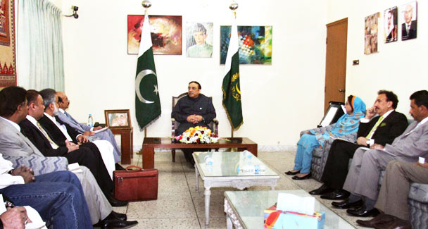
A delegation of Lyari MNA’s, MPA’s, party office bearers of PPP Karachi Division and Lyari called on President Asif Ali Zardari at Bilawal House on January 12, 2010.
Interior Minister Rehman Malik blames the land and drug mafias, backed by enemy agents, for the targeted killings in Karachi.
To the MQM’s Farooq Sattar these killings are the work of Lyari gangsters backed by PPP elements. Sindh Chief Minister Qaim Ali Shah has acted wisely in not naming the MQM.
Both the PPP and MQM are partners in the Sindh coalition and have pledged not to let the killings divide them. The gang wars and body bags are but a gruesome representation of the mistrust that presently runs through public life — more visible in Karachi than elsewhere.
The country’s second largest party — the PML-N — doesn’t trust the president, nor do the chief ministers their governors. The judges are wary of the legislators. Both are wary of the civil servants. In this atmosphere of mistrust, it is no wonder that the ruffians that every party has, kill and get away with it.
Violence is never far from the surface in an unstable and unjust society. It floats close to the surface in the ghettoes of Karachi where the older inhabitants and later migrants rub shoulders in an often explosive mix. Belonging to the party in power brings them jobs and amenities not accessible to other slum dwellers.
This is a broad explanation for the targeted, or random, deaths in Karachi. Killing or getting killed is not for a cause but for the protection of a job or a shack. The political leaders fully exploit that sense of insecurity or despair to their own advantage.
The present series of murders has been ostensibly triggered by differences among the political parties in the Sindh coalition over the future of the district governments. In a way responsibility for the mayhem lies with their leaders — and it is up to them to call a halt to it. While engaged in interminable negotiations, any show of strength or nuisance by the workers or bullies would enable the leaders to wrench a favourable deal.
That is how politics and violence have come to exist side by side. Only a conclusive agreement (the Sindh governor has said that differences pertaining local bodies polls have been sorted out) on the jurisdiction and powers of local councils and more specifically of the city district government of Karachi, and to a lesser extent of Hyderabad, would bring this murderous cycle to an end.
Over the last eight years the ministers and legislators could not but watch and growl while district nazims handed out jobs and dispensed other favours which previously lay in their domain.
Under the local government law uniformly enacted in 2001 by Gen Pervez Musharraf for the four provinces (which they lacked the authority to amend until the end of 2009), district nazims rose to be powerful rivals of ministers and parliamentarians. The influence and patronage they commanded in their constituencies passed into the hands of the nazims. The financial allocations from Islamabad for the districts, especially Karachi, had to pass through the provincial government but unscathed.
The key to peace in Karachi therefore lies in finding a balance of power between the nazim (the council hardly ever mattered) and the provincial set-up. This balance, though administrative, has enormous political significance. The nazim of Karachi presently is from the MQM and is likely to remain so in the foreseeable future. That can also be said about the PPP heading the provincial government, though with less certainty.
In this context the two parties must truly collaborate to administer the province as a whole. In the present arrangement the MQM shows little interest in rural Sindh and the PPP feels altogether excluded from Karachi and other cities. The test of their statesmanship lies in devising a formula under which the district and municipal councils (call them governments if you will) remain in existence but as an extension of the provincial government and not as rival entities that look up to the central government or to their party high command for funds and political support.
The provincial government, on the other hand, must not seek to reduce the district governments to the status of councils and municipalities of the past that it could suspend or supersede at will. The district governments on their part must also realise that they no longer can have the clout, funds and fun that they had in the Musharraf regime.
Some simple rules can be laid down to ensure continuance of the local councils and to safeguard their jurisdiction. The first should be to protect the councils in the constitution just as the assemblies are. The governor should be able to suspend or dissolve a council only in such circumstances as the president can the parliament.
Second, law and order, revenue, lands, irrigation and highways must remain in the provincial jurisdiction. Third, developmental and social functions should be divided between the two. For example, higher education, hospitals and inter-city transport should be with the province but primary/secondary schools, community health and urban transport with the councils. Fourth, for the execution of large infrastructure projects, the sponsoring or financing agency may decide who is to execute and maintain them. Fifth, the local councils must have their own service cadres raised in the same manner as are the provincial services.
Since the functions of the councils will be civic and developmental, their elections should not be on a party basis. In fact politics should be kept wholly out of local government. The murders in Karachi’s Lyari and adjoining quarters must not be dismissed as a mafia war or a foreign conspiracy. Maybe there are elements of both but chiefly it is discontent in that community and a justified apprehension that in a district government headed by an MQM loyalist they cannot get their due share in civic amenities or jobs.
The violence may now recede for a while but will keep recurring if mistrust at the top and a feeling of injustice persist down the line. However, a question that keeps haunting is: who is in charge here? Everybody was on the scene but the nazim, whom the law requires to “perform all functions relating to law and order”.

