Land, jobs and murders
By Kunwar Idris
Sunday, 08 Aug, 2010
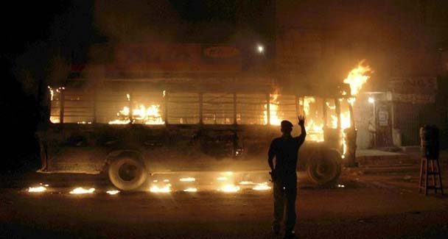
Although violence takes an ethnic colour, its roots lie in maladministration.—Photo by Reuters

Local
Five suspected gangsters shot dead in Shanti Nagar

Five suspected gangsters shot dead in Shanti Nagar

The ongoing violence in Karachi is routinely attributed to a fight among ethnic groups over jobs and lands. That, by and large, is correct.
The solution, like the problem, is simple. The dispensation of both jobs and plots should be under the law and by a neutral body. But ethnic leaders, one and all, would be wary to agree to that for laws will preclude the favouritism and corruption that are the staple of our politics.

Laws can be designed to protect racial, regional, minority and other legitimate interests but the procedure must give an equal chance to compete to all those who are eligible.
If this principle were to be applied to jobs and land allotment, there should arise no grievance or trouble. The cause of discontent lies in an unwritten, unethical compact among the bosses of all parties that they will hand out jobs or plots to whomsoever they like. The motive can be as varied as favouring a kin or rewarding a crony or plain bribery. Merit would be incidental.
Violence tends to take an ethnic colour in Sindh but its roots lie in maladministration. The battle against communal or ethnic discrimination would have been won if government jobs and lands had been taken out of the equation. In vocational pursuits there is no clash; in fact there is interdependence.

For the most part, Pakhtuns run the transport system in Karachi — buses, taxis and rickshaws — which mohajirs hire to ride to their shops or homes. Pakhtuns are a hardy, toiling lot ready to do the chores that mohajirs won’t do. The mohajirs are more into skills. Together they keep the wheels of the economy turning.
The animosity between the two communities dates back to Ayub Khan’s victory procession in 1965 that ended in mayhem. Since then the past has been buried more than once but the leaders dig it out continuously for their politics are sustained by hard ethnic cores.
It is wholly unacceptable that supporters of parties that are ostensibly partners in the Sindh government are allegedly killing each other on the streets while their leaders revel in power and patronage.

One reform measure could be to cut the cabinet size to 10 ministers and do away with hundreds of hangers-on. It is preposterous for the chief minister to have 17 advisers at public expense who have no standing in the public.
A wider source of conflict with an ethnic dimension is the changes made over the last 30 years in administrative boundaries and service structures, not for public welfare but for ethnic hegemony or to bring administration, particularly the police and land management, under political control.

The head of the district police was made answerable to a political nazim and commissions formed for public safety and crime control never functioned. The system introduced by Gen Musharraf hasn’t worked but professional hierarchies have been destroyed. The deputy commissioner, who was the coordinating head for law and order, revenue and land utilisation, was virtually reduced to the status of a staff officer to a nazim representing a party.

After 30 months in office the present government has shown no inclination nor has found the time to review the system which didn’t work then nor is working now. It is not known when the local government institutions will be revived but this must happen to administer civic affairs and development.

Law and order, land management and other regulatory affairs must revert to professional administrators. Not that all decisions or deals would then be fair but they wouldn’t be outright partisan either. The organised land mafia has come up as an adjunct of the new system. Before that there were touts who could bribe but not coerce officials.
Ideally public affairs, and more particularly law and order and government lands, should be managed by professional civil servants with the ministers overseeing affairs to ensure that policy and law are not breached. The relationship between local councillors and the provincial government should also be governed by the same principle.
This principle is of special importance in Sindh where districts have been split only to establish the hegemony of a clan or an ethnic group. A commission should now review whether there was any justification for tampering with long-established district boundaries.

The justification for splitting Karachi city into 18 towns, which on the face of it looks arbitrary and absurd, must also be reviewed. The reduced number of districts should then have career administrators for regulatory subjects and elected nazims, call them mayors if you will, for development.
The killing spree in the wake of an MQM legislator’s murder which so far has claimed 90 lives (and the toll keeps mounting) is an indicator of the ethnic sensitivity of crime in Karachi. One keeps wondering what kind of reaction to terror will help retrieve the ideal of Pakistan that is fast receding in the shadows of religious and ethnic conflicts.
Interior Minister Rehman Malik finds it handy to blame one or the other outlawed sipah or lashkar for targeted killings or mass murders.

Two suicide bombers were captured alive and handed over to the authorities by Ahmadi worshippers in Lahore. And in Karachi evidence is being gathered about the recent spate of killings.

If our intelligence and investigation agencies are still unable to identify and catch the culprits, British Prime Minister David Cameron’s allegation that elements in Pakistan’s ‘establishment’ are backing terrorists could win more adherents here at home and abroad.
kunwaridris@hotmail.com
If you want to follow news on your mobile, click on http://dawn.com/mobile/ and download Pakistan's first mobile news application.

