Deweaponising Karachi
By Huma Yusuf
Sunday, 08 Aug, 2010
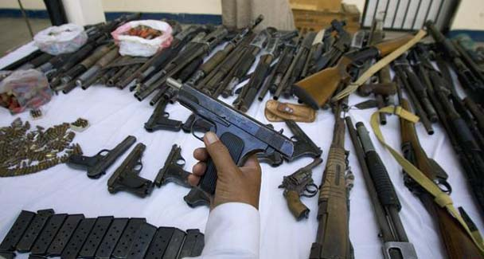
Eliminating small arms is the only solution to Karachi’s persistent turmoil.—Photo by AP
“If you want to save Karachi, the face and index of Pakistan, then deweaponise it.” These wise words were uttered by Azam Swati, minister for science and technology, in the Senate on Thursday as the Karachi killings continued unabated.
But they are words we have heard before, from Gen Pervez Musharraf in the wake of the May 2007 violence; from former interior minister Moinuddin Haider during the deweaponisation campaign of 2001; and countless times in between over the past decade.
The term ‘deweaponisation’ has become a strong candidate for inclusion in the mantra of meaningless phrases uttered by our politicians in response to severe security lapses, along with ‘inquiry,’ ‘foreign element’ and ‘destabilise’.

And yet the only concrete government response to the recent killing spree — the issuance of shoot-on-sight orders — contradicts the goal of reducing small arms in the city, and instead aims to fight fire with fire.
The prime minister on Friday established a commission to investigate the recent target killings and identify perpetrators on all sides. In the past, such commissions have failed to deliver, and suspects are often acquitted by anti-terrorism courts for lack of evidence.

The commission could better serve the people of Karachi by brainstorming ways in which to make the dream of deweaponisation a reality. Eliminating small arms is, ultimately, the only solution to Karachi’s persistent turmoil.

Sadly, it is also one that requires the most strategic thinking, institutional commitment and capacity, and financial resources. In the chronic absence of these, the people of Karachi have little cause for optimism.
Innumerable policy reports have documented how the availability of unregulated arms fuels instability and undermines development initiatives. Proliferating small arms are known to spur insurgency, terrorism, and the formation of urban gangs and militias.

This is something Karachi residents have experienced on a first-hand basis since the 1980s, when Kalashnikovs poured into the city as a side effect of the anti-Soviet ‘jihad’.
Interestingly, a 2004 report on the security impact of small arms by the Community Appraisal and Motivation Programme, a Peshawar-based NGO, warns against blaming the Afghan ‘jihad’ for the weaponisation of Pakistan.

The report points out how successive governments facilitated the spread of firearms in society by implementing liberal licensing policies and waiving built-in checks, such as mandatory police verification, which would allow authorities to monitor citizens who possess small arms. This means that the government is now in a position to draft policies that undo previous damage and facilitate deweaponisation.
In 2001, the government adopted the United Nations Programme of Action on Small Arms and Light Weapons and launched a campaign to counter the rampant ‘Kalashnikov culture’. While well intentioned, that initiative did not go far enough — even though it had its work cut out.

According to the Small Arms Survey, only two million of the estimated 18 million arms present in Pakistan at the start of this decade were legal (thanks to the war against terror, the number of illicit arms is believed to have soared since then). Under Musharraf, illegal weapons were confiscated — but only in the thousands.

Moreover, despite campaigns in 2001, 2005 and 2007, the previous government never fully implemented the ban on the display of weapons or took serious steps to monitor or halt the issuance of arms licences.
The present government should not be surprised then when its promises to crack down on illegal arms ring hollow with the people of Karachi. We will now settle for nothing less than a comprehensive, multi-pronged strategy to get the guns off our streets.

To begin with, the government must introduce more stringent legislation to regulate weapons manufacturing, trade and licensing. The private production, import, export and transit of arms are prohibited under the law, but it is not illegal to purchase weapons from an illegal manufacturer or supplier. This is a significant loophole in the law of the nation that houses Darra Adamkhel, where over 100 weapons factories illegally produce several million arms annually.
Significant funds must also be allocated to train law enforcers in how to track and confiscate weapons, manage armouries and munitions depots, and destroy illegal small arms.

The state will also have to invest in modern equipment — such as computerised databases and specialist shears that crush small arms — needed to support deweaponisation drives. Of course these measures can only prove effective if police reforms are pushed through and the complicity of the authorities in arms smuggling is minimised.
Plans to engage local communities in deweaponisation efforts are also a must. Many creative solutions have successfully been implemented in Africa and the Middle East: weapons buyback programmes, the digital tagging of registered weapons for tracking purposes, and mobilisation of youth and women to gather illegal weapons during amnesty periods.

In many African countries, boxes have been placed in violent communities where locals can submit anonymous notes providing information about arms trafficking and caches.
More broadly, deweaponisation has to become a foreign policy goal. Over 600 million small arms are currently in circulation globally, and there is no shortage of international networks of arms smugglers.

Transparency International identifies the weapons trade as one of the most universally corrupt. Even if Pakistan takes up the fight against illegal arms, it cannot win without the cooperation of Afghanistan, Iran and other regional players.
Given the infrastructure and vision required to truly deweaponise a society, it is unrealistic for our senators to make demands that cannot be fulfilled without the consensus of all political parties and major urban stakeholders, including land mafias and traffickers. Such a consensus will be hard won in the foreseeable future.
In the meantime the government can express its concern about rampant weaponisation by rethinking the decision to hold the sixth International Defence Exhibition and Seminar (IDEAS) in Karachi this December. Under the guise of ‘arms for peace’ this arms fair provides a platform for domestic and international manufacturers in an attempt to make Pakistan a major regional trading zone for small arms and military hardware.

The fallout of this trade policy will no doubt be the further weaponisation of Pakistan. Given the events of the past months, it would be insensitive and inappropriate to flaunt more small arms, and that too in Karachi.
huma.yusuf@gmail.com

