Web of silence?
By Huma Yusuf
Sunday, 14 Feb, 2010
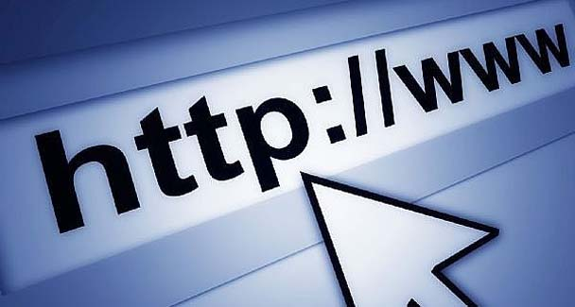
Concerns about online free expression grew last year after the passage of the Prevention of Electronic Crime Act.—File photo
Pakistanis have always had a taste for delicious ironies — and we can always count on our leaders to serve them up. The latest treat comes from none other than President Asif Zardari.

In a recent speech, while speaking about democracy, Zardari paused, glared at a heckler in the crowd, and then shouted at him to “shut up!”
This being the 21st century, the not-so-proud moment was caught on camera and widely circulated via the video-sharing website, YouTube.

Those who saw the clip were already tittering about the irony of democracy’s greatest defender shushing free speech in such a literal manner when the Pakistan Telecommunication Authority (PTA) decided to up the ante. Since last Sunday, links to the video have been blocked and anyone trying to view the clip is informed that the ‘site is restricted’.
Moreover, on Friday, the webmaster of the ‘Make Pakistan Better’ website reported that the PTA has also directed that the site be blocked on an Internet protocol level. The webmaster alleges that the site has been blocked for hosting anti-government content, though the PTA has cited no reason for the clampdown.
These are not the first instances in which websites have been blocked. In October last year, websites hosting a video that showed a Pakistan Army major interrogating people suspected of harbouring terrorists was blocked — the clip revealed that the major ordered his team to beat the suspects. In August 2008, the PTA blocked links to a video alleging the misuse of power by naval chief Admiral Afzal Tahir.
Before that, during the February 2008 elections, links to a video that showed election rigging by a major Karachi-based political party were blocked. In that instance, the PTA drew global attention to its censorship tactics — as well as the limits of its technical know-how — by blocking the YouTube website around the world for a few hours.
The authorities also sporadically block the websites of Baloch nationalist groups. In fact, online activists have been fighting against Internet censorship since 2005, when the PTA blocked hundreds of blogs hosted on the ‘blogspot.com’ domain.
Concerns about online free expression skyrocketed last year after the passage of the Prevention of Electronic Crimes Act, mention of which is often preceded by the use of the adjective ‘draconian’.

In yet another ironic twist, our civilian, democratically elected government passed the act even though it was a vestige of Gen Pervez Musharraf’s regime and encapsulated his increasingly authoritative attitude towards press freedom.
Much has already been written about this legislature, which aims to curb cyber terrorism but employs vague language that could be invoked to slap serious charges on anyone who owns a computer.

Under the act, the PTA can arbitrarily invoke hazy definitions for what constitutes spamming, spoofing, stalking, ‘terroristic intent’, or a terrorist act to put someone behind bars for years. Indeed, the act is peppered with words such as ‘lewd’, ‘obscene’, and ‘immoral’, which are not legal terms and are thus highly subjective. In other words, it is up to the authorities’ discretion to determine what is unacceptable.
For months, there have been calls to redraft the law and to bring it in line with international legal standards for cyber crime as well as the International Covenant on Civil and Political Rights and the Universal Declaration of Human Rights. The PTA’s decision to block a YouTube clip and a website recently are reason enough to renew that call.
Admittedly, Pakistan does not have the poor track record of China, Iran, Saudi Arabia, Egypt and other countries that restrict online free expression by filtering or blocking content or monitoring activity — at least till now.

But it is absolutely essential that the Pakistani authorities do not go down that route, for it is an affront to press freedom at large and would be another setback to this country’s newest exercise in democracy.
The fact is, online monitoring and blocking are modern versions of old-school tactics to rein in a free press, such as detention, harassment and intimidation. Around the world, attacks against bloggers and other individuals who post content online is the first front in authoritarian crackdowns on press freedom.

After all, individuals who go online are more vulnerable to censorship than professional media personnel because they do not have the backing of organisations or unions, nor do they have adequate resources such as money, lawyers or awareness about their right to free speech.
Until now, the PTA has only blocked a handful of websites. But Internet connectivity is becoming widespread — according to Internet World Stats, there are currently 18.5 million Internet users in Pakistan, a 13,716 per cent increase from 2000.

As more youngsters go online, we are bound to see a new generation of citizen journalists posting video clips, images or blogs that document official transgressions such as corruption or torture.

To ensure that their right to do so is protected, we must speak out now against the PTA’s blocks as well as the cyber crimes act that support such actions.
There is already a push in the US and EU to include violations of online free expression in countries’ human rights portfolios. If we do not set a precedent for protecting online free speech, the PTA’s activities could become yet another issue that makes us pariahs among the international community.
Pakistan has long prided itself on having a relatively free press, and military dictators and civilian governments — when flagging their democratic credentials — point to the open conversation in the country’s column inches and on its airwaves. The government should make a policy decision to extend that conversation into the Pakistani websphere.

