Where did displaced Aids patients go?
By Ashfaq Yusufzai
Wednesday, 10 Jun, 2009 | 12:45 PM PST |

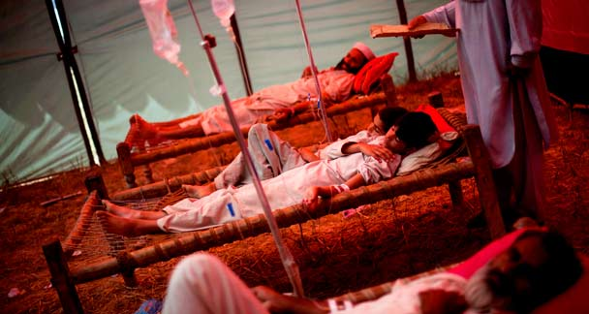
Since the military operation’s start, the 50 registered HIV/Aids patients in Swat, Buner and Lower Dir couldn’t be accessed. — AP

Pakistan
Health care in Pakistan crumbles under refugee burden

PESHAWAR: The NWFP health department is concerned about the missing HIV/Aids patients as most of them could not be accessed after start of the ongoing military operation in the Malakand Division.
‘We had 50 registered HIV/Aids patients, 35 male and 15 female, in Swat, Buner and Lower Dir districts but after beginning of the military operation, the patients couldn’t be accessed,’ an official said.
Sources say that the patients may have died while attempting to leave their native areas in hurry or could be staying back at home.
Officials at the antiretroviral therapy centre of the Hayatabad Medical Complex (HMC) have traced only 12 patients while the mobile and landline telephone numbers of the rest of the patients were either not responding or were found switched off.
There is an urgent need to trace the patients from the conflict zone so that their treatment at the HMC could be continued. Discontinuation of treatment could lead to their deaths, officials say, adding that the Frontier province has 392 HIV/Aids cases, 276 of them were male, 96 females and 20 children. Most of the HIV positives belong to Swat, Upper Dir, Lower Dir and Buner.
According to the Provincial Aids Control Programme, there is no information on the whereabouts of the patients after the new situation developed in the volatile region.
The problem exacerbated by the fact that various primary health units had been operating in the IDP camps providing basic healthcare and running OPD on regular basis, but none of them specifically dealt with HIV patients.
Officials say that about 40 pregnant displaced women visit the District Headquarters (DHQ) Hospital Mardan on daily basis but there is no gynaecology OPD like the DHQ hospital Swabi where about five displaced pregnant women are being examined everyday. Patients are referred to the Shah Mansoor Medical Complex Swabi for HIV screening.
There are 311 school camps in Swabi with 10,866 displaced persons but the health facilities are not available there and only mobile health teams visit them randomly. In view the dismal situation, the health department has planned to start HIV screening at relief camps.
In Mardan the situation is more or less the same where four relief camps and 1,187 schools, housing the IDPs, had not even mother-and-child healthcare facilities in a proper way. Pregnant women visit the DHQ hospital Mardan for antenatal care and delivery. About 40 pregnant women visit the hospital everyday.
In Peshawar, about 20 women require antenatal check-up at the Katcha Garhi Camp on daily basis where health teams would be imparted training on HIV screening, officials say.

