Interview with Foreign Minister Shah Mehmood Qureshi
Muneezay Moeen
February 6, 2021
MM: What initiatives has Pakistan Tehreek e Insaaf government taken to shift the foreign policy pro Pakistan in its tenure?
SMQ: To get an understanding of it we need to know the intentions and agendas of our rivals that are solely to malign Pakistan globally. We have witnessed that Indian network has been aggressively promoting disinformation. According to the EU DisinfoLab, the mission of this network is to discredit nations in conflict with India in Asia especially Pakistan and China. In order to accomplish their mal practice this network created NGOs, think tanks and ‘fake’ news media outlets which would influence the European Parliament and create the impression that pro-India, anti-Pakistan interests have support in European institutions. The network even repackages and disseminates news through Indian wire agency ANI, as well as little known media networks in 97 countries, to amplify anti-Pakistan content. Shockingly, the network resurrected a dead professor by using his identity and used 750 fake media outlets to push its propaganda. India aims to isolate and de stabilize Pakistan in the region the core and initial objective of Pakistan’s foreign policy was to hamper Indian objective of isolating Pakistan.
India is always planning to make a stronger case at the Financial Action Task Force (FATF), to get Pakistan blacklisted for terror financing but Pakistan successfully till to date has made progress across all action plan items and has now largely addressed 21 of the 27 action items. The Pakistan related entry on the FATF website also mentioned that since 2018, when Pakistan made a high-level political commitment, the country has led to progress in a number of areas in its action plan including: taking action to identify and sanction illegal MVTS, implementing cross-border currency and bearer negotiable instruments controls, improving international cooperation in terrorist financing cases, passing amendments to the Anti-Terrorism Act to increase the sanctioning authority, financial institutions implementing targeted financial sanctions and applying sanctions for AML/CFT violations, and controlling facilities and services owned or controlled by designated persons and entities.
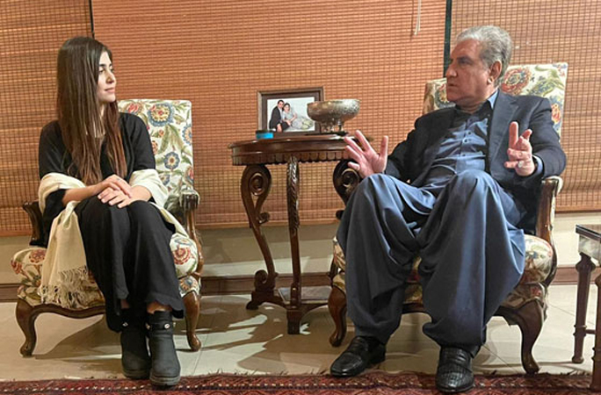Pakistan played a vital role in intra afghan negotiations and its constructive role and facilitation of the Afghan peace process has been recognized by all sides and the international community.
CPEC has now entered second phase. It brings a new set of opportunities and chance to enhance benefit from the first phase.
We have shifted from geo politics to geo-economics. Prime minister envisions that if the foreign policy is economically stable and independent, Pakistan cannot achieve the set target of foreign policy.
MM: What practical measures have been taken in Engage Africa policy and how beneficial will it be for Pakistan?
SMQ: Pakistan has successfully shifted from geo-politics to geo-economics and economic diplomacy is a key component of modern diplomatic practice. we witnessed that this initiative had started paying off, with a 7 percent growth in Pakistan’s trade with Africa, despite the Covid-19 related challenges. Pakistan has envisaged “Engage Africa Policy” to strengthen its ties with all African countries as a key part of its foreign policy. We embarked on the ‘Engage Africa’ initiative aiming to expand Pakistan’s diplomatic footprint and deepening economic engagement with Africa by encouraging envoys to cultivate and broaden mutually beneficial trade and economic partnerships with African countries, focusing on key goals of trade promotion, financial inflows, investments, remittances, tourism and technology transfer.
MM: How do you foresee JoeBiden as President of America, will he be playing a balancing role in region or it will have ties with India?
SMQ: America has terms with India and one cannot turn eye from it and Pakistanis need to know that America has bipartisan consensus whether it was Trump ,Bush ,Clinton or Obama’s administration. to contain in South Asia, it is understood if they are allies to each other, but the presence of Pakistan is also very certain. In afghan peace initiative America led Pakistan to bring afghans on table and Pakistan’s role as a facilitator in the Afghan Peace Process is quite beneficial to the state. By being back at the negotiating table with the major regional powers, Pakistan hopes to improve its relations with other states whereas for India it was not possible.
MM: Is there any development in suspension of debt repayments for the most stressed countries until the end of the pandemic as proposed by the prime minister of Pakistan?
SMQ: Prime minister of Pakistan has observed that developing countries are trapped between recovering from the pandemic and meeting their debt servicing obligations. Referring to his call last year for a global initiative on debt relief for developing countries including Pakistan, he said “much more needed to be done” in this regard or else achieving the sustainable development goals by 2030 would be a dream. the world is facing global economic contraction. we see in the neighboring countries where global contraction is10.3 pc in India, 6 pc in Iran etc. it’s a challenge for Pakistan to maintain in this time.
Our primary fiscal deficit has been changed into surplus.
Those who say that debt ratio in contemporary government has increased need to make sure that it is the interest of previous government that is adding on and it’s our obligation to pay it. Our efforts to reduce inflation are now showing results and we are making effective strategies to counter social and economic issues.
MM: Pakistan ranked 124 out of 180 countries – dropping four spots over last year – in the newly released Corruption Perceptions Index. What in your perceptive is the reason that perception of people is not changed in regards of corruption?
SMQ: It is certain that Pakistan drops four spots on Corruption Perceptions Index. The report is an annual index that ranks countries based on perceptions of public sector corruption. The 2020 edition of the CPI ranked 180 countries and territories by their perceived levels of public sector corruption out of which Pakistan is ranked 124.we need to know that maximum data is not of our time but a little. There is time lapse in survey and publication. a very Important agenda of manifesto of Pakistan Tehreek e Insaaf is the eradication of corruption. we ensure open and transparent contracting to combat wrongdoing, identify conflicts of interest and ensure fair pricing, and defend democracy and promote civic space to create the enabling conditions to hold false doers accountable.
MM: clampdown in occupied Kashmir by the Indian government has brought life to hell for Kashmiris. How will Pakistan rise against Indian aggression in Kashmir?
SMQ: Pakistani Prime Minister Imran Khan has been firm and straight forward with regard to Kashmir policy, as his government uses bilateral talks and raises the issue internationally. However, India’s move to abrogate the special status of the Kashmir Valley in August 2019, which observers expect to result in demographic changes in the valley, has been significant. It was the first occasion where India made a unilateral move disregarding earlier agreements, resulting in the failure of bilateral talks.
Since 5 august 2019, UN Security Council has discussed over Kashmir thrice. matter of Kashmir and human rights violations we have the statement of house of commons and now it is eminent that Kashmir is not the internal matter of India. The ruling Bhartiya Janata Party has espoused this idea for decades. Similarly, Pakistan’s outrage was inevitable too. It sees its chances to control Kashmir weakening as a result of Modi’s move. The heated rhetoric and rising tensions over Kashmir are causing concern worldwide. for seventeen months there has been unbelievable economic loss in Jammu and Kashmir. Tourism, handicrafts, greenery and all that added value to Kashmir is destroyed. International human rights organizations are now criticizing India which was earlier not seen.
MM: What initiatives has government taken to establish business counters and strategies globally?
SMQ: Pakistan has drafted the strategy of economic diplomacy in which mapping is carried out to identify the challenges, benefits and opportunities in the region. An Envoys Conference on Africa was held in November 2019, followed by the first ever Pakistan-Africa Trade Development Conference in Nairobi in January 2020. I met the African continent ambassadors and conversed on how can we further excel our economic partnership. In February I will engage with Europe. Recently I invited the European ambassadors and exchanged thoughts regarding what initiatives can be taken to excel the economic partnership between European states and Pakistan. Furthermore, we intend to Establish better economic ties with America and gulf countries. we ensure to stabilize the economic indicators.
MM: Which countries are allies with Pakistan?
SMQ: Our foreign policy is friendly .Pakistan has good relations with neighboring countries that include Afghanistan Iran china .long term strategic engagement plan with European union was signed in brussels referring to the growing momentum of the Pakistan-EU relations based on the Strategic Engagement Plan signed in June 2019 and agreed to make efforts towards its comprehensive implementation in all areas of cooperation, including through strengthening of existing and new institutional engagements. Pakistan has friendly terms with all 57 Islamic states. We intend to have friendly relations with India as well but it is engaged in staggering scale of anti-Pakistan propaganda as always.
The writer is a human rights activist, a blogger

