Worthless rote learning
By Humair Ishtiaq
Sunday, 24 Jan, 2010
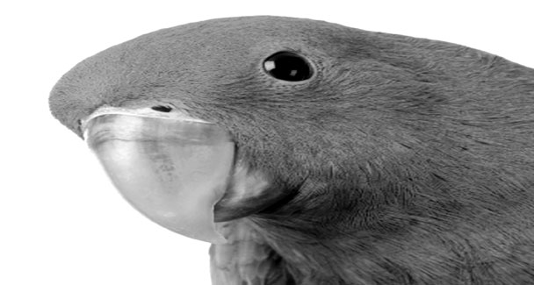
ONE of the ways in which the education system enables us to treat ourselves with psychological lullabies is by way of bombarding young minds with non-stop clutter related to what great strides our ancestors made in various fields when the rest of the world was living in the dark ages. This could be an important piece of information if conveyed in its proper context, but since it is not done, it simply falls in the realm of rote learning.
The system, its managers and its various functionaries fail to realise the simple fact that all the advances made by Muslim scientists — and, indeed, by others — could come to fruition only because they stayed away from the meaningless rote.
This has been happening for so long that the students of yore have turned into teachers of today. As a result of such misplaced consistency, the national psyche has been completely tranquilized with the laurels of Muslim scientists of medieval ages. This naturally takes nothing away from the scientists. What they did was obviously great. But there are enough grounds to question why it all came to a grinding halt. It is only by understanding the reasons behind such a massive downfall that we can ever hope to keep such reasons at bay and move on with dignity and pride.
As things stand today — and they have been that way for an irritatingly long time — one of the reasons why we are not taken with due seriousness among the comity of nations is our inability to contribute much, if anything, to humanity’s march towards a better tomorrow. While we enjoy the bounties of multifarious research that is carried out across the globe, we remain part of the “other” world that has proved itself incapable of making a contribution to the key phenomenon that is taking a long-term view of life on earth and even beyond. For reasons that are not totally incomprehensible, this “other” world is largely considered to be an entity with parasitic tendencies to latch on to the “functional” world for which it has become a sort of excess baggage to carry along.
A bit abrasive though it may sound, it is what it is like in real-life terms. Even worse is the fact that we do not actually deserve to carry this unflattering tag. Pakistanis, for sure, are enterprising people and the country does have the resources, both natural and financial, to indulge in meaningful research that will ultimately set quite a few things right. The problem lies with the lack of focus within the national policy-making infrastructure.
We have nuclear technology, which is not available even to some of the most advanced nations. Acquiring it was a long, arduous, uncertain and tricky path, but there was policy-level consistency on the issue and that made it a consistent effort which kept the momentum going regardless of who was running the show at any given point in time. The result: unadulterated, unqualified success.
Away from all the various debates surrounding the issue, there is no denying the fact that this was no ordinary achievement because the nation could become self-reliant in a technology that nobody in the developed world wanted us to have and everybody wanted us not to have.
Isn’t it ironic that the same nation that defied such heavy odds has struggled to put things right in areas where it faces no such constraints? Say, for instance, in health sciences, manufacturing technologies and such other areas. Apparently, this does sound paradoxical, but the reason is not hard to fathom: focus and consistency of policy in one area and lack of it in the rest. There can hardly be any ‘ifs’ and ‘buts’ on the issue.
All the relevant offices in the country — the federal and provincial education ministers and their ministries, the Higher Education Commission, universities, education boards and so on — have always made the right noises. But they have remained just that: noises.
There is a need of a thread that may run through them and convert this clutter into hardcore action and ensure that the pace is sustained in the long run. For this to happen, top-tier policy on education needs to be accorded the same status that was enjoyed by nuclear acquisition. Easier said than done, but rote learning is not taking us anywhere anyway … and it never will. Let’s give us some chance to imitate our lofty ancestors. Please.

