The power of (il)literacy
By Humair Ishtiaq
Sunday, 07 Feb, 2010 | 12:50 AM PST |
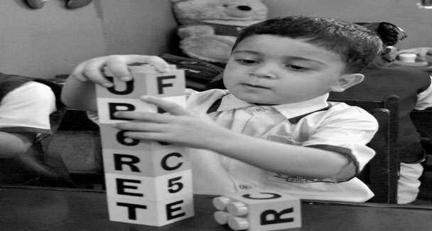
MINISTERS, bureaucrats and officials of various shades and hues are not particularly known for an honest word in public. Rhetoric has been their preferred mode of expression for so long that a change of individual in office doesn’t have much of an impact on its conduct. Sindh Education Minister Pir Mazharul Haq, however, seems to be an exception.
Speaking at Mirpurkhas recently, he conceded that it would be difficult to achieve the target of Education For All (EFA) by 2015 “because of faults in the system”. This was the first time anybody in a position of authority had said what the people knew even on the day when the government of Pakistan had become signatory to the global EFA document.
This is not to suggest that the country has done nothing to move towards the 2015 deadline. It definitely has, but this has not been enough. An honest statement makes people feel more confident in the system. On the other hand, blatant lies and rhetoric to justify existence and continuation in office don’t sell in this day and age. This is something that our politicians, bureaucrats and technocrats have yet to learn.
In 2005, a member of the federal cabinet had talked of one hundred per cent literacy by 2015. A year later, another minister told a Senate Standing Committee meeting that though 100 per cent was the target, she was not sure whether it could be met. Then came the head of the National Commission for Human Development in 2008, who brought it down to 86 per cent. And finally, the admission by Pir that the target would not be met. Though he didn’t talk about the expected distance from the target, his choice of words suggests it will be pretty much. As 2015 draws nearer, we are bound to get more realistic assessments.
On the occasion of the World Literacy Day late last year, President Zardari had proposed the formation of a high-level National Literacy Council (NLC) to “ensure the launching of a well-coordinated and effective literacy drive throughout the country”. It was to have the prime minister as its head and was to include chief ministers and federal and provincial ministers of education, finance and planning as its members.
If Gen Musharraf could have his HEC, Mr Zardari was within his rights to think about having the NLC. Though the temptation may be strong, one would be well advised not to draw parallels with the other NLC — the National Logistics Cell — which is known, among other things, for building bridges that some time cave in.
The NLC might have been a brilliant idea on its own and one would have liked to believe that an honest beginning had been made, but the fact is that Pakistan’s public expenditure on education as a percentage of GDP is one of the lowest in the world and has been constantly going down. It was 2.50 per cent in 2006-07, 2.47 per cent in 2007-08 and fell to just 2.10 per cent during 2008-09. Unesco had recommended a minimum of six per cent in order to be anywhere close to the target.
The theme of the Unesco-led Day was “The Power of Literacy”, but we have been simply overwhelmed by the power of illiteracy and it takes a brave man to even talk of the EFA target and Pakistan in the same breath. In 2008, a Unesco report on its EFA initiative had placed Pakistan among the 10 worst performers alongside Eritrea, Mozambique, Ethiopia, Benin, Guinea, Mali, Burkina Faso, Niger and Chad. Quite a company to be in, really.
The honesty expressed by Pir Mazhar needs to be duly appreciated. But just as one was beginning to do that, he proved that after all he was a human being, and, indeed, a Pakistani government functionary. From Mirpurkhas, he moved to Mithi and, addressing a gathering of the locals, announced that profiles about great educationalists including the late Sachal Janjhi “who rendered significant services for the promotion of education in Sindh”, would soon be included in the curriculum. One does not need to be there to be sure of the enthusiastic cheers and clapping that would have followed this announcement. After all, the minister was talking about honouring a local hero at the provincial level.
There were a few people in the gathering, however, who chose to talk more about action than words. They reminded the minister about his announcement several months ago that the dilapidated building of Sachal Government Boys’ High School would be reconstructed, and pointed out that nothing had been done in that regard. The minister, apparently bitten by some honesty bug that day, immediately “admitted his fault”. Moral of the story? Honesty alone is not enough. Words not backed up by action mean nothing.

