Path to prosperity
By Khurram Zia Khan
Sunday, 14 Feb, 2010
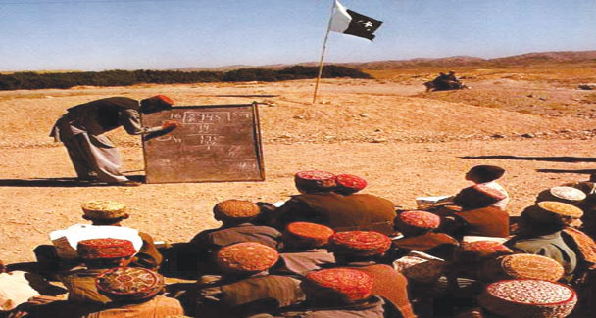
Pakistan now in its 63rd year of existence is still unable to develop an education structure assuring proper access to education for all sectors of our society.
All the ills in our society are attributed to the prevailing low literacy rate. We as a nation need a strategy to improve the education ratio and take steps to spread literacy at the grass root level.
On the contrary the overall education structure, especially school education, is going into the hands of the business community which seems more inclined towards earning money than impart quality education to the masses.
The standard of education in government schools is only deteriorating and as most of our rural population is dependent on government school education, the students living in the rural areas are struggling to compete with the people of urban localities.
The people of the interior of Sindh and Balochistan are the most-effected due to a dearth of quality schools in their locality. Recently, I came to know of a kind of visa system prevailing in the schools of interior Sindh. The system has a teacher appointed by the education department paying a part of his salary to his senior and another sum to an un-educated friend to stand in his place and teach the students while the teacher himself goes to some other area preferably a city for another job.
The people belonging to villages around Thatta and other areas where this system is practiced are pleading for its abolishment but their cries have so far fallen on deaf ears.
Teaching standard in government schools at least in the urban areas used to be good in the early days of Pakistan’s existence but the standard continues to fall so much so that now even parents who find it difficult to make ends meet show reluctance in sending their children to government schools.
Pakistan at this point is in need of some serious steps from the government as well as the private sector to revamp its deteriorating education system.
Our government as per the budget of 2009-10 is spending only two per cent of its GDP on education and it plans to spend seven per cent of its GDP on education in the years to come.
The current expenditure is obviously very low. It will not be enough to tackle the ills of our education system. Onus is now on the private sector to take measures for providing better education to the people of this country but again you only see the business community coming forward to open schools with the sole purpose of earning.
These private school owners charging exorbitant sums from the parents are but paying a very low amount as salary to the teachers. After having a brief discussion with some teachers of different Karachi schools, I found that a teacher’s salary is equivalent to the tuition fees of two children. Because of the low salaries, the teachers, too, feel burdened. They find it hard to concentrate on their jobs which in turn can affect a child’s future.
It is a sad reality that the quality of education enjoyed by the children of the elite class is far greater than what is available to students whose parents’ earnings are modest.
As a greater part of the population hails from the middle or low-income bracket, the majority of the students coming from our education system are average people struggling at carrying out their professional duties in an amicable way. This in turn hurts the country’s progress as the products of our education system just don’t have it in them to lead or take charge. They are mostly governed by someone from a different level of society. It brings in the mindsets of seniors and subordinates, something that won’t change until you have a change in the entire system starting from basic education.
It is time we rebuilt the education system. Some of the steps taken must include transfer of education system into the hands of those who love to impart education. Providing education instead of earning big money should be their sole motto.
After-school tuitions are also a big menace. Not only are they a burden for the child they are also a pain for the parents, who have to cough up the tuition fee along with the school fees. Besides, there is obviously something lacking in school education that the parents are trying to cover through tuitions.
A lot of work also needs to be done in the rural areas including the construction of proper schooling facilities, appointment of qualified teachers besides making sure that the appointed teachers teach in the schools where they have been appointed. Pakistan, as compared to the other countries, is rapidly falling behind in all sectors of the world and the biggest reason for this decline is our low education rate.
Education, if utilised effectively, is the only tool that can help us compete with the other countries in the world.

