Injecting the human factor
By Sher Alam Shinwari
Sunday, 21 Feb, 2010
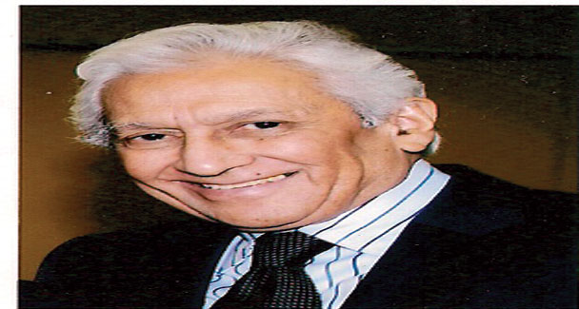
Besides being an eminent doctor, Prof Dr Sirajuddin Ahmed former principal, Khyber Medical College, (KMC), Peshawar, and dean faculty of medicine, University of Peshawar, is also a fine teacher trainer.
Born in Peshawar on August 13, 1935, he did his MBBS from King Edward Medical College, Lahore, in 1958 and received further medical education from Edinburgh and Glasgow, UK, followed by postgraduate training from the USA.
Having served in various capacities, Dr Siraj took his retirement in 1995. He is also the author of two books — How to prevent Aids and Quality Education. In addition he has contributed 25 research publications to reputed journals and attended numerous seminars, workshops and conferences on health and medical education here as well as aboard.
Sharing his views on the plight of medical education in Pakistan, Dr Siraj says that there is an absence of the human factor in the so-called healers that we produce. Regard for a patient’s emotional wellbeing is a far fetched cry, therefore, the respect and sacredness associated with the medical profession has gone down the drain in this part of the world.
He adds: “When I used to be a part of the interview board responsible for short listing students for admission in medical college, many of them would exhibit little humanitarianism despite excellent academic performance. The fault lies with the education system which does not encourage inquisitiveness, critical thinking and a sympathising attitude.”
Drawing inspiration from his father, a dedicated school teacher, Dr Siraj pioneered the idea of having a training programme for medical teachers in Pakistan. He first thought about this during a workshop where he observed that medical teachers lacked the ability to teach while inspiring their students.
“The idea dawned when I saw doctors teaching without knowing how to do it properly. They didn’t have a clue about how to instill within them a sense of regard for the ailing people besides keeping an emotional attachment with the medical profession. Not only should they know how to overcome the disease, they should also be able to win over the patient in doing so.
“The idea was translated into reality by launching a series of medical teachers’ training seminars, workshops and symposia in all the country’s medical colleges. The feedback was quite encouraging though we still have a long way to go,” he remarks. “Doctors busy in private practice have no time for fresh research and innovative methods,” he says.
Dr Siraj favours primary education in the mother tongue but also suggests drastic changes in the syllabus.
“Basic education should be given in the mother tongue while national [Urdu] and international [English] language should also carry on right from the beginning,” he says.
“We need to reset our national aims and objectives according to the rapidly-changing global scenario and our social requirements. The obsolete way of transmitting outdated knowledge to passive receivers must end. Policymakers should focus on introducing an interactive way of education, which can transform our classrooms into practical laboratories producing individuals that in turn transform the nation,” Dr Siraj maintains.
Regarding female education, he says: “We have kept half of our population in utter darkness due to our failure in educating females. We cannot produce self confident, questioning and inquisitive children in the absence of an educated mother. Without the complete participation of women in every sphere of life, we as a nation would never be able to confidently step forward.”
He observes: “I don’t know why we are so afraid of empowering our women; it is in fact man’s empowerment as it will only lead to his burden being shared and the household problems being minimised.”
He added: “Non implementation of the educational policies in their true letter and spirit and the lack of political will are the main causes behind Pakistan’s deteriorating education system. A large number of children here are out of school. Many of them work as labourers and scavengers while many turn into addicts, beggars, thieves, etc. In the backdrop of the worst law and order situation, they fall into the hands of militants.
“If these children are brought back to the schools and given quality education in order to encourage analytical and critical thinking within them, they would never be distracted or brainwashed. But unfortunately, 80 per cent children in this class-ridden society attend public sector schools which paints a gloomy picture anyway while children from the poor class are sent to religious seminaries where untrained and sometimes semiliterate teachers pass on to them a distorted version of the religion,” he regrets.
“Still, with there being no dearth of talent here, all is not so bad. Our children only need chiseling, the right direction to follow in, constant evaluation and there is no reason why a well-trained teacher can’t mould their outlook towards life and the way of doing things.”
Speaking about the corrective measures, Dr Siraj suggests to the stakeholders to take practical steps, update both short and long-term objectives, create resources for proper execution of plans and introduce new subjects in the curriculum and a righteous evaluation and monitoring authority to overhaul and oversee the whole educational process from top to bottom.
“The biggest anomaly of education in our system is that it produces graduates that become parasites for society. Most degree-holders play no practical role in society as they don’t have any technical skill to do so. Tolerant society can only emerge when there is a respect for freedom of expression,” he recommends.
“Therefore our education should become interactive, market-oriented, inclusive of all the classes leading to national integration, economic empowerment and women’s emancipation,” he concludes.

