Education needs assessment
By Zubeida Mustafa
Wednesday, 10 Feb, 2010
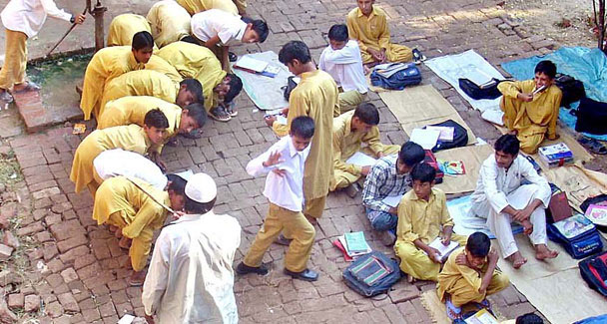
A testing system should be an inbuilt mechanism to monitor how students and schools are faring.
The Pakistan Education Task Force (PETF) has now been constituted and we have been told that it is a short-term body that has been created to address the issue of access to and quality of school education.
Shehnaz Wazir Ali, the co-chairperson — the other is Sir Michael Barber, the British education consultant — has said that the PETF will identify clear goals for improving the school system.
Ms Wazir Ali has indicated that the tenure of this body will be 18 months. One wonders how in this short span of time the PETF will determine its goals, when we have not even identified the problems and their solutions. The education policy announced last year is not very clear or comprehensive on this count. One may speak in general terms about improving quality, but one needs to be clearer about the changes one is looking for if targets are to be set.
The most positive aspect of the task force is that it is to focus on school education only. If public-sector institutions can be visibly improved a momentum will be created for reforms in education at all levels. Even the low-fee private schools that are not up to the mark will be compelled to upgrade themselves in terms of quality — or perish. Logically, their enrolment could fall when students have the option of schooling in free government institutions that start performing.
There was a time when government schools were ranked as the best. In support of this claim, Dr Parween Hasan, who was director, educational research, Karachi Board of Secondary Education, drew my attention to two publications of the board evaluating the performance of schools and students who appeared for their SSC examinations in 1974-87. This is an interesting period which saw the full impact of the nationalisation-denationalisation-privatisation policy in the country.
An analysis of the merit scholarship holders establishes two significant trends which the education task force would do well to examine. First, in 1975 more than a quarter of the top positions were taken by students of government schools (excluding the nationalised ones). If the nationalised schools (that were mostly low-fee institutions comparable to government schools) were included the ratio went up to nearly 75 per cent.
It was only after the quality of public-sector schools declined sharply in the 1970s that high-fee private schools came to the forefront and their students grabbed over 80 per cent of the merit positions in 1987.
The second trend to emerge was that children from Urdu-medium schools were performing better initially — in 1975, 80 per cent of the positions went to them. In 1987 this trend was reversed and English-medium schools took 90 per cent of the positions in the SSL examinations.
This should provide some food for thought to our planners who have been focusing on the private sector and English as the medium of instruction — thus junking the government institutions.
It would also be helpful to the task force to look into the findings of various studies that have been carried out recently, most notably the Learning and Educational Achievement in Punjab Schools (LEAPS). Testing children close to completing the third grade, the study found that in mathematics most children had the competency set by the education ministry for first-graders. In English only 29 per cent were able to fill in correctly a single blank letter to form a word. The students fared equally badly in Urdu, indicating the poor state of language teaching.
These were random tests but their findings were confirmed by the four cycles of tests conducted by the National Education Assessment System (NEAS) in 2005-08. NEAS was introduced as a five-year project by the government with funding from the World Bank and the UK’s Department for International Development.
NEAS developed a national testing system with the idea of “measuring learning outcomes and thus improve the quality and effectiveness of programmed interventions”. Students of grades four and eight were examined in mathematics, science, social studies and language. Marking on a scale of one to 1000 and keeping 500 as the desirable score, NEAS found the average score in maths to be 421 and 369 in Urdu in the tests held in 2005.
Private schools participated in the exercise only in 2008 but their scores were not incorporated in the overall results. Professionally done, the sampling was pretty representative.
Most importantly much effort was invested in collecting background data that is needed to correlate the various inputs in education to the outcomes. Comprehensive questionnaires were given to students and parents, head teachers and teachers to identify the factors associated with student achievement. They sought information on the socio-economic background of students, home environment, the teaching process, school climate, teaching aids and so on.
The idea of such an assessment system is to provide guidelines to policymakers on curricula, textbooks, pedagogy and parents’ involvement to achieve optimal competency. In fact a checklist can even be developed on that basis for supervisors to monitor when they visit schools. The follow-up to NEAS did not take place and the National Education Policy 2009 was drawn up without heeding NEAS findings.
Countries which have such testing systems in place use it as an ongoing tool to monitor school education not with the idea of testing students to determine quality but as a research facility to decide what is good and what is not. Tests held every year also help to show if a strategy is producing desired results. Therefore all schools — whether private or public — must participate in this exercise.
It was therefore encouraging to learn that the government has decided to restart NEAS. This is being described as the second phase. Is it to be temporary? A testing system should be an inbuilt, institutionalised, permanent mechanism to monitor how students and schools are faring. Only then can any fall in competency be investigated right away and corrected. How else can the education ministry “maintain education standards” as it is legally obliged to under the act of parliament of 1976?

