Education and values
By Ayesha Siddiqa
Friday, 05 Feb, 2010
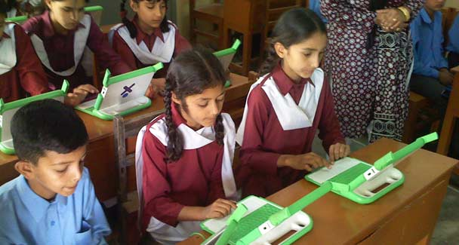
The coexistence of various economic classes also meant greater tolerance for other differences, be it class, religion, caste or creed.
A year ago, some of my old classmates from Lahore’s Cathedral High School tracked me down through the Internet. I can’t be grateful enough for this wonderful invention in communications, and the patience of this crazy bunch that wanted to travel back through the time tunnel.
The conversations of the class of 1981 continue; it is fascinating to go back in time, think about all those people and yourself, and then see how each has grown. All the people in our chat group are well settled and excel in what they do. Quite a few seem to have shifted to North America and have become successful doctors, engineers and management experts. I suspect that the majority are engineers and doctors since we belong to a generation whose parents could not see beyond these two professions.
A bright mind had to pick one of the two areas which left others, whose hearts were not in either field, quite out of sorts with themselves. You could not pretend to be bright without wanting to join either of the two vocations. Deciding for yourself was rare. So, the new generation has far more options.
But as I sat exchanging notes with former classmates and trying to remember the faces in some old photographs that we shared, it struck me that we had the privilege of studying in an institution. Moreover, we grew up in a value system that was grounded in a middle-class narrative. Looking at the photographs, I could recognise a classmate whose father owned a bakery in Neela Gumbad, Lahore (not a chain of stores but a single shop). It struck me that the overall value system and the educational institutions that produced our group did not cater to the class divide.
There were a range of such educational institutions, including Cathedral High School, St Anthony’s, Sacred Heart, Queen Mary’s, Divisional Public School and many others that were quite well grounded in middle-class values. These schools acted as melting pots where individual social realities had to soften enough to create ease for whoever else was part of the institution. While there were schools like Aitchison, which was socio-economically a class above, the others were generally at the same level.
The reason that Cathedral High School and other such institutions offered this was linked to the fact that they were run by different Christian missionaries or similar set-ups. This meant that upper-class children had to learn to survive with less affluent ones. So, while the Convent girls were generally reputed to be a bit ‘up in the air’, even they had to study with children whose fees were subsidised by the mission. This led to social intermingling that watered down the class barriers to a large extent.
Also, the fee structure was quite affordable. I remember our parents kicking up a racket when in 1977 the fees were suddenly jacked up from Rs50 to Rs75. Those were certainly not the days when children brought cellphones to school or got obnoxious amounts of pocket money. I remember us being warned to stay away from one child: he allegedly got Rs10 from his father every morning — there’s got to be something wrong with money doled out with such ease!
The coexistence of various economic classes also meant greater tolerance for other differences, be it class, religion, caste or creed. During the morning assembly, we would sing hymns followed by the national anthem. There was generally no fear of being induced to convert to another religion. At our school, students from all religious backgrounds had the option to join the choir, which some found attractive because it occasionally allowed you to skip a class to go to the cathedral for practice. (For a long time, one popular myth was that there were ghosts inside the cathedral, which naturally kept the majority away.)
It was not that all the students at this and other such schools came from upper-middle class families. The majority was middle class and yet liberal enough to allow a bakery owner’s daughter to attend a co-ed school. There were many others like her; there were children whose parents owned businesses, including in Anarkali, and others who came from the households of professional and educated parents. That was a value system that allowed the coexistence of many colours, sounds and smells. There was lesser tendency to create unfathomable compartments.
But all of what I have described was the case before society became flush with money. The ’80s witnessed the systematic strangulation of pluralism and multi-polarity. This was achieved through several methods, but certainly through changing the tenor of the socio-economic and educational systems. In the first category you could see changes regarding people’s behaviour towards money: the source of the money did not matter and, in fact, not having money or having less of it started to become a stigma. (A year ago I heard my five-year-old niece ask her mother about the model of their car; apparently, such questions are now not considered weird.)
The other major shift related to education, which fell prey to a process of rapid de-institutionalisation and capitalism. Suddenly, there was a mushrooming of new schools with fancy names, which aimed at establishing a class above the rest — based on money. Questionable sources were certainly not a problem. The more expensive the school, the greater a symbol of high status it became.
Schools gradually became places where you bought education without any baggage of values or responsibility towards society. The teachers began to be treated like they were the parents’ personal staff, there to keep the brats entertained. The social background of your classmate also became important. I remember being told about a school for children of the staff of a prominent university; the majority of the academic faculty had reservations about sending their children to a school that was also attended by the children of the staff.
Unable to compete in terms of money and good human resources, schools like Cathedral High crashed and it is not a place where I would today send my child. However, I am indebted to the school and our teachers for giving us more than just the ability to read and write; I am sure the class of ’81 will agree that studying in an institution was a great privilege.

