Booking your child’s future
By Tahreem Wasti
Sunday, 20 Dec, 2009
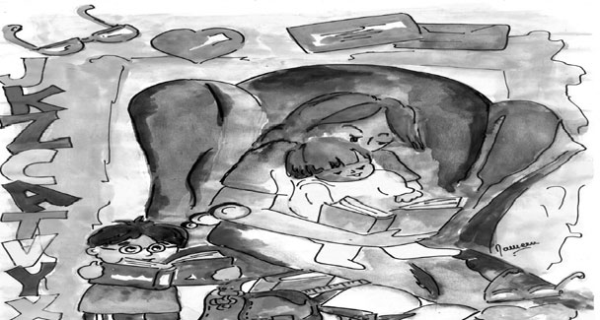
Some of the earliest memories I have are of my mother reading aloud to me and my siblings from story books, and books of nursery rhymes. My imagination took such a fancy to those engrossing tales that I began weaving up stories of my own, often enacting them out through my dolls.
I began to read novels and classics, and would ask for books for my birthday presents. I remember how proud I was when my father made me a shelf for my increasing pile of books, just above my writing desk. Those quiet evenings when my mother used to read to us have resulted in my becoming what I am today - a “bookaholic”.
Numerous researches emphasize the importance of reading aloud to your child from an early age. Reading to young children is one of the very best things that parents can do for them. Infants will delight in being cuddled and hearing the calming voices of their parents, even though they don’t understand the words.
As children get older, parents can introduce them to picture books and nursery rhymes. Even at a young age, they will discover that books are read from front to back, and that pictures stand for real objects.
Peggy Gisler and Marge Eberts, who are both experienced teachers and supervisors at the Butler University Reading Centre, write in an article high
lighting the advantages of parents reading aloud to children: “Reading to young children is excellent preparation for formal reading instruction in school. When you read to them, you are building pathways in their brains needed for successful reading experiences. They will be developing auditory perception that allows them to think about how words sound. Furthermore, reading stimulates children’s language development as they are like little sponges, imitating everything they hear. Listening to stories will enhance their vocabulary and help them use longer sentences.
“Another wonderful plus in reading to children is that it increases their attention span and the ability to focus to what is being said. In addition, reading makes children more curious — a trait that must be fostered in young children or they will never acquire it. And of course, their knowledge of the world will expand. More than anything else, reading to young children gives them a desire to read. Many children, who are read to when young, begin reading on their own without any formal instruction.”
This awareness is fast spreading among young parents, more so than it ever did a decade ago. Aqsa Owais, a freelance artist currently living in London, UK, with her husband and nine-month-old son, says that she takes her son, Salik, to the local library everyday.
“I know Salik is too young to absorb anything I read to him at this stage, but I want him to familiarise himself with the environment I am introducing him to. When he starts understanding things, he will see these visits as a daily routine, something which is an ordinary part of his life, and I hope it will help instill the love of reading in him.”
Another young mother, Dr Ainee Kizilbash, has similar views. “I definitely believe that starting to expose children to books from a very early age and making it an important part of their lives results in a lifelong love for learning and education. My son is now 18 months old and comes to me with books, asking me to read them to him. I do not really expect anything in particular from him at this time but over the next couple of years if I can teach him how to read, I will feel very accomplished as a parent. Reading will provide him with all the tools he needs for self learning for the rest of his life.”
There are many secondary school students, however, who lack the basic appreciation for good books that makes a child a reader. Parents and teachers should both aim to help such a child make reading a permanent habit. The parents can take a number of steps to ensure that their child reads quality books. First and foremost, forcing the child to read will never instill that love for reading that is being strived for here. All that this will accomplish is that the child will see reading as a chore, an equivalent to homework. What is important is to encourage the child to read on his own accord.
Make trips to bookstores, or a nearby library, a family affair. If public libraries are not an option, make use of school libraries. Take the help of the school administration, teachers and the school librarian to ensure that the library is stocked with quality literature, such that children will enjoy reading, and at the same time, will help in awakening the child’s imagination, and Write to us at education@dawn.com
in stimulating his/her mental agility. Parents should also make it a habit to carry a book with them everywhere they go, especially to places where waiting is a usual process (for example, a doctor’s appointment). Children mostly mirror their parents, and watching parents taking such interest in books will help them try to do the same.
Teachers, on the other hand, can introduce fun ways to make students enjoy reading. Recommending short stories is probably the first step, as giving a child a full-length novel to read in the first instance will act as an instant deterrent. The teacher can then encourage students to comment on how they liked the story, which parts they liked best, and which might have been better. Gradually, the teacher can introduce lengthier books, and prompting oral and written discussions on them.
Hundreds of advantages result from the development of a steady reading habit. Improved vocabulary, better writing skills, and enhanced comprehension understanding abilities are only some of the benefits mentioned above. Illustration by Naureen Wasti
Needless to say, it is a valuable skill to develop in oneself and one’s children. Having said this, Matilda may not look like such a fictious character anymore … minus the superpowers, that is!

