All under one roof
By Kausar Zobairi
Sunday, 31 Jan, 2010
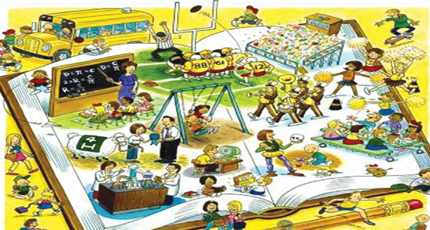
Even before we can grasp innovations or transformations in ideas, styles or techniques there is another one popping up in front of our eyes.
Our schooling system needs a breakthrough. We should switch over to a more practical system, one that merges with the enterprising society of the new century, and is effective for children, teachers and our new generation of females, determined to enter the entrepreneurial arena.
Women are a strong workforce. They know they have to take on the home and work side by side yet they are up for the challenge. Proving their level of ambition, countless resumes of aspiring women professionals arrive for a single job opening in an establishment. For these daring females of our country already running on the track during the time when their children are at school, the home remains an important factor in their decision to go on.
Which mother doesn’t have dreams for her offspring? Their children alone are reason enough for them to continue without stopping for even a breather. But it has been seen that in the limited five hours (8.00am to 1.00pm) that the children spend at school, the amount of time allocated for academics as well as extracurricular activity is so minimal that the parents feel obliged to fill up the available time slots later in the afternoon or evening for these activities at other places outside the home.
Children’s education does not cease when the school shuts its gates every afternoon. There are tuitions, advanced religious exposure, coaching in games, martial arts, music as well as cooking or sewing classes to attend. Obviously students excel when parents pay a price.
The question consequently is that besides regular academics, can schools in every community embrace these evening classes in their daily timetable? Can they cater to the children all under a single roof by increasing the number of school hours on a national scale?
This conglomeration, I visualise, will have overwhelming results. Parents will drop their loved ones to an educational institute once a day instead of running around, racing against time. Above all they will save money and related anxieties. The mothers will get more time for their jobs, too.
It is futile to languish over administrative matters related to educational institutions like the unexpected public holidays, the debate on five- or six-day school during a week, plus the disturbances created by power shutdowns. I personally believe that one eminent power that dominates over the pace of progress at home and over a nation as a whole is the number of hours children spend in constructive learning at schools. But with only half the day spent at school, such a proposition seems far-fetched.
Children avail exposure to knowledge from more than one source and every new generation is faster in learning than the previous one. So inclusion of two or more hours can have an inconceivable outcome. For a metamorphosis we must seriously and impartially consider its introduction in all the cities and small towns.
Working women in their role as teachers as well as students, especially young students will benefit the most. The majority endorses that subjects such as natural sciences, social sciences and mathematics require more time to be well comprehended and retained. Unless children are given sufficient time and motivation for questions of curiosity to be aroused in their minds according to their own respective levels, a teacher cannot give assurance of mathematical or scientific inclinations, which is in fact the essence of education.
For example at the primary level when the topic under study is the structure of a leaf, the students only copy a diagram of a leaf from the picture in the book. They are not allowed the luxury of time to be taken to different gardens and personally observe and discover the vast variety in nature.
The teachers complain about shortage of time. The most a teacher can do at a regular school is to complete the syllabus for the exams because that is what is required of them. Scurrying through lessons due to shortage of time lays the foundation of home tutoring or for some children their registration in tuition centres.
In schools where the bell announcing end of school for the day rings at 4.00pm, homework as well as extra help or learning support programmes are well taken care of. Senior school students too avail their teachers’ attention due to their presence while carrying out research-based assignments.
Academics then become the responsibility of only the school teachers and the exhausted working mothers don’t really have to bother about sitting with their kids for hours or paying a substantial chunk of money to get them tuitions in different subjects.
If the amount spent on tuitions is dropped from the family budget, the parents will save money as well as the physical exertion and anxiety involved in scheduling their children’s daily routines. It is in any case a ridiculous idea to send a child to a regular school in the morning and a tuition centre in the evening. How much a tired child gains from a tutor and how much of it he loses on the road in traffic jams in the evening needs some genuine assessment.
It is also a misconception that longer school timings deprive a child of his rights at home when in fact the student who has left school at 4.00pm can have quality time available to care for personal hygiene, bonding with siblings and the development of hobbies.
It is a fact that when children come home early, they actually waste their precious time in entertaining themselves more by indulging in all varieties of media entertainment and electronic games, which in effect blocks creative mental ability as well as triggers violence and emotional distress in them.
A few among other fringe benefits are lunchtime in the school cafeteria where the menu is fixed and health-oriented. It actually teaches a child to be less fastidious and rigid about one’s food likes and dislikes. Similarly, music classes, where children have the option of selecting an instrument like a keyboard, flute, violin or guitar, teaches them to become conscious of the naturally existing rhythm and harmony on Earth.
Added facilities would mean addition in fees, too, but when one critically works it out, there is more of a gain than loss. Also when their children don’t have to be left with neighbours, hired maids or alone unsupervised just because they are off from school too early to be coordinated with their mothers’ working schedules, the latter will be mentally and physically more at ease, too.
Developing countries such as ours should try implementing this idea in the schooling system as most developed countries have already been following it since decades. There is perhaps a relation between the time spent in an institutionalised environment where learning and team work are the focal points and the intellectual output later in life.

