A decalogue

By Dr Maria Montessori
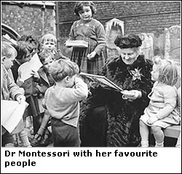
(August 31, 1870-May 6, 1952)
• Never touch the child unless invited by him (in some form or the other).
• Never speak ill of the child in his presence or absence.
• Concentrate on strengthening and helping the development of what is good in the child so that its presence may leave less and less space for evil.
• Be active in preparing the environment. Take meticulous and constant care of it. Help the child establish constructive relations with it. Show the proper place where the means of development are kept and demonstrate their proper use.
• Be ever ready to answer the call of the child who stands in need of you and always listen and respond to the child who appeals to you.
• Respect the child who makes a mistake and can then or later correct himself, but stop firmly and immediately any misuse of the environment and any action which endangers the child, his development or others.
• Respect the child who takes rest or watches others working or ponders over what he himself has done or will do. Neither call him, nor force him to other forms of activity.
• Help those who are in search of activity and cannot find it.
• Be untiring in repeating presentations to the child who refused them earlier, in helping the child acquire what is not yet his own and overcome imperfections. Do this by animating the environment with care, with restraint and silence, with mild words and loving presence felt to the child who searches and hide from the child who has found.
• Always treat the child with the best of good manners and offer him the best you have in yourself and at your disposal.

