The travails ofB M Kutty: Part –V
September 16, 2019

Dr Naazir Mahmood

In the fourth part of this series on B M Kutty published on September 9 in these pages, we discussed how he felt disgruntled by the petty squabbles of the leaders of the Communist Party of Pakistan (CPP), especially by Imam Ali Nazish and Prof Jamal Naqvi.
In this last two-part column we look at the event of the early 1970s up to the dismissal of the NAP government in Balochistan, and leave the rest to some other series at some other time. First, we recall that after the 1965 war between India and Pakistan, most of the communists in East Pakistan remained pro-Russia, whereas most comrades in Punjab turned pro-China.
The CPP in Sindh had an understanding with their comrades in East Pakistan, and that’s how Nazish Amrohi and Prof Jamal Naqvi with some other communists in Sindh tried to assert it as the ‘real’ pro-Russia party, with the exclusion of Punjab where pro-Russia elements were nearly extinct. The CPP leadership from East Pakistan, especially Mohni Singh and Prof Muzaffar Ahmad, advised the CPP in Sindh to reform itself as the West Pakistan Communist Organizing Committee. That’s how, according to Kutty, the Sindh CPP ditched its pro-China comrade Aziz Salam Bukhari and appointed Imam Ali Nazish as the general secretary of the organizing committee.
Mohni Singh also advised the Sindh Unit to include senior left-wing politicians Mir Ghaus Bukhsh Bizenjo and Gul Khan Naseer in the committee as representatives from Balochistan. In Punjab, Shamim Ashraf Malik was perhaps the only prominent communist who remained pro-Russia. Mind you, the CPP was still legally banned and it was working either underground or within the National Awami Party without overtly using the CPP tag. When the NAP was divided, most of the pro-China communists joined the Bhashani NAP, whereas the CPP Sindh and Shamim Ashraf Malik from Punjab associated themselves with the NAP faction led by Wali Khan.
The 1966, the organizing committee had in its fold S A Malik from Punjab, Nazish and Naqvi from Sindh, Bizenjo and Naseer from Balochistan, and Ajmal Khattak from the NWFP (now Khyber Pakhtunkhwa). And the top-level secretariat had a troika of Malik, Naqvi, and Nazish. Kutty does not have kind words for Naqvi and informs us that when Nazish was underground, Naqvi exercised real power and made unilateral decisions that enraged other party leaders and that members, especially the young cadre, decided to leave the party in 1967; they were led by Dr Sher Azfal, Anwar Ahsan Siddiqui, BM Kutty, Hadi Naqvi and Faisal Durrani.
Some senior comrades such as M R Hassan and Anis Hashmi (whose granddaughter Sania Saeed is a famous actor now) remained with the CPP for a while more, but ultimately left it for the same reason. After the division of the NAP, the first convention of the Wali NAP was held in Peshawar in 1967 in which communist members also participated and exchanged their views. G B Bizenjo and S A Malik expressed their displeasure at Jamal Naqvi’s attitude and suggested that the CPP secretariat be shifted to Lahore, but Naqvi resisted.
For the next seven years, that is till the NAP was banned, the communists kept working within its fold, the CPP remained underground – with Nazish as secretary in hiding and Naqvi as the main stumbling block for its expansion, as observed and reported by Kutty. From 1970, Kutty narrates a sad event in which Poland’s deputy foreign minister was killed at the Karachi airport.
Kutty gives an eyewitness account of how the president of Poland arrived in Karachi on an official visit; being a member of the Pak-Polish Friendship Society, Kutty was also present to receive him. When the president of Poland disembarked and met the governor of Sindh, right on the tarmac a PIA catering van driven by a bearded man, who later confessed to be a member of a religious group, rammed into the dignitaries. The target was the president of Poland who was missed, but the deputy FM was hit and killed. The security personnel took the president back to the airplane where he waited for ten hours for the dead body to be handed over. The president of Pakistan, General Yahya Khan, didn’t turn up at the airport to condole with the president of Poland who cancelled his visit and flew back to Poland.
Recalling the events preceding the 1970 elections, Kutty testifies that though the General Yahya regime did not directly interfere in the elections, state functionaries provided financial and other support to many smaller parties so that the votes could be divided and no single party could form the government. General Yahya wanted to exercise his presidential powers in the formation of any future government. According the Kutty, the PPP of Z A Bhutto, the Muslim League of Qayyum Khan, and other smaller groups were General Yahya’s favourite to blackmail the Awami League of Mujibur Rahman.
The 1970 elections were the first direct elections after 1954 in East Pakistan. Balochistan was polling for the first time; the NWFP and Punjab had their first elections after 1951, and in Sindh it was the first direct election after 1953. The results produced the Awami League as the largest single party able to form government; this startled the military junta of General Yahya Khan who cancelled the election results and started a military operation in East Pakistan in March 1971. Nine months and a war and surrender later, the country broke up and Z A Bhutto assumed power in the rump Pakistan in December 1971.
Z A Bhutto decided to side with the ruthless and much hated politician, Qayyum Khan, who had a long history of malice against the Bacha Khan family and the NAP which now was able to form provincial governments in Balochistan and the NWFP. This decision of Z A Bhutto to adopt Qayyum Khan as an ally alienated the NAP from the PPP and hampered any future reconciliation and cooperation for democracy. Kutty recalls that Z A Bhutto kept delaying talks with Wali Khan without any result. Wali Khan got so irritated that he handed over the task to Bizenjo.
Finally in March 1971, a trilateral agreement was signed with the JUI and the NAP as allies and the PPP as the federal government. NAP governors were appointed in Balochistan and the NWFP and provincial governments were formed. The NAP was clearly a socialist party which alarmed Iran and the US. The king of Iran saw the NAP government in Balochistan as a direct threat to the Irani Balochistan. So now, the Jam of Lasbela and Nabi Bakhsh Zehri led by the federal interior minister, Qayyum Khan, joined hands to destabilize the NAP government.
In May 1972, the princess of Iran, Ashraf Pehlavi, visited Quetta and Qayyum Khan sent a private mercenary force to protect her. Kutty was an eyewitness to all these developments as he had become pretty close to the NAP leaders – especially with Mir Bizenjo who was now the governor of Balochistan. Kutty had been drafting most of the press statements of the NAP leaders who appreciated Kutty’s astute understanding of politics and his flawless English. Kutty acknowledges that the Urdu translations were done by Hadi Naqvi. On April 28 1972, Bizenjo became the governor of Balochistan and both Hadi and Kutty were invited by the new governor to join his team in Quetta.
Hadi returned to Karachi after a few days, but Kutty continued with Bizenjo as his political secretary and saw the conspiracies against the NAP government from close quarters. Siddique Baloch who had worked for the daily ‘Dawn’ became Bizenjo’s press secretary. In the last part of this series, we will discuss the nine-month democratic government of NAP in Balochistan.
To be continued
Email: mnazir1964@yahoo.co.uk
The writer holds a PhD from the University of Birmingham, UK and works in Islamabad.

Latest News
- 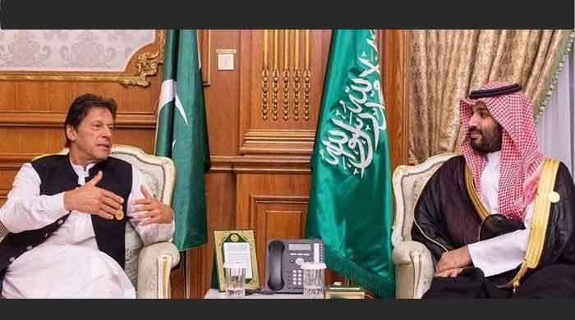

PM Imran Phones Saudi Crown Prince, Condemns Attack On Oil Facilities

- 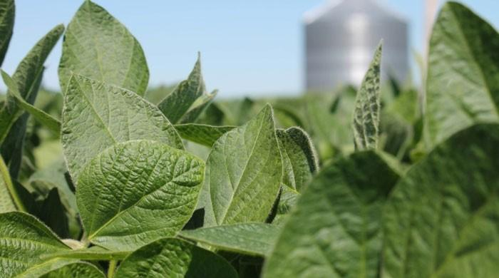

Poor Countries Will Need To Increase Carbon Footprint To Address Hunger: Study

- 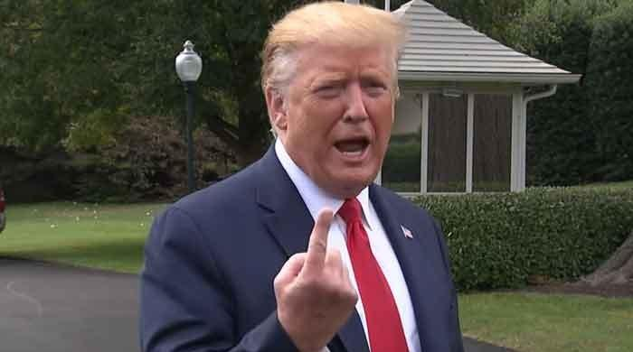

Trump Rages As NY Times Clarifies Its Kavanaugh Story

- 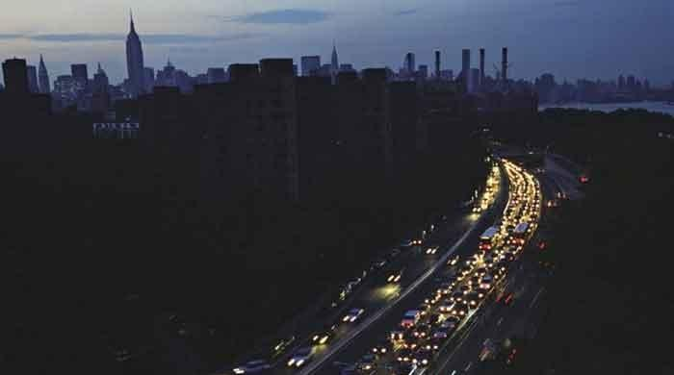

Huge Power Outage Hits Much Of Central America

- 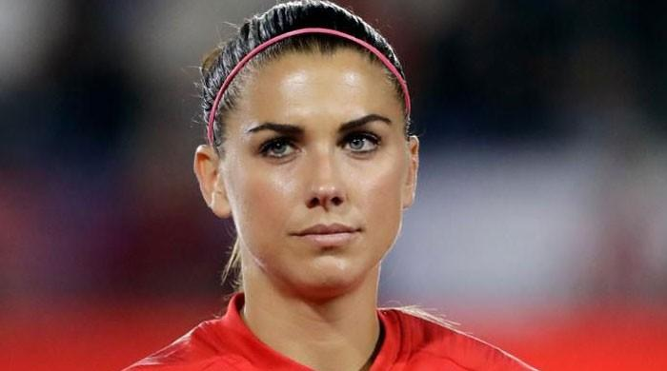

US World Cup Star Morgan Ruled Out For Rest Of 2019 Season

- 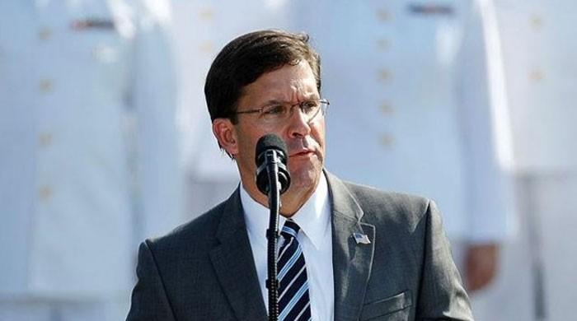

US Will ´defend´ International Order Being ´undermined By Iran´: Pentagon Chief

- 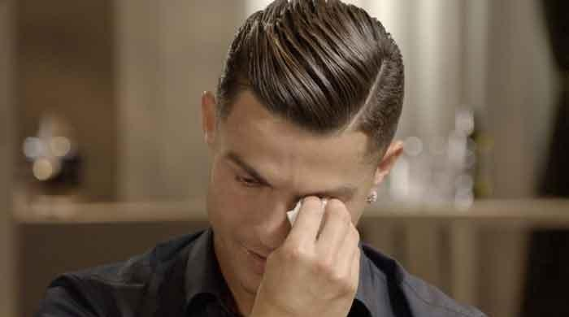

Ronaldo 'embarrassed' By Rape Allegations

- 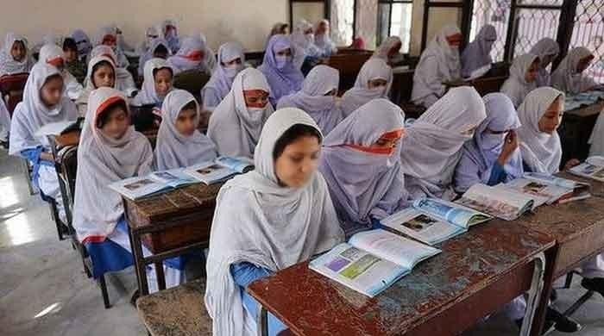

KP Govt Withdraws Notification On Dress Code For Schoolgirls

- 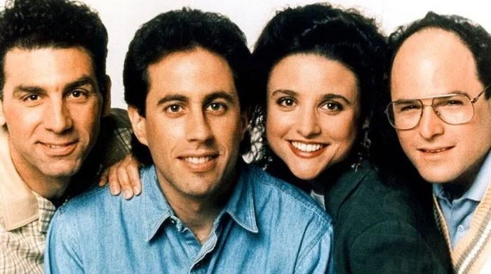

After Losing ´Friends,´ Netflix Buys Rights To ´Seinfeld´

Topstory
- Normalise IoK situation, Indian SC to Modi
- Fake accounts case: NAB summons Sindh CM in Karachi today
- Pakistan tracks down two Indian spies in Mastung
- India’s brutal clampdown continues for 43rd day in IOK
- SBP keeps interest rate on hold at 13.25pc
- View more...

Opinion

Newspost

Editorial

National

World

Sports

Business

Karachi

Lahore

Islamabad

Peshawar

