The civil and military gazette

By Anjum Niaz
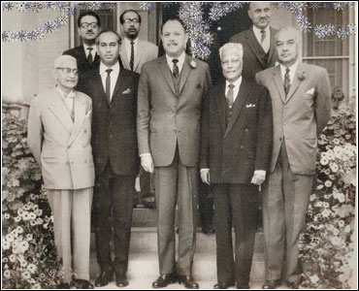
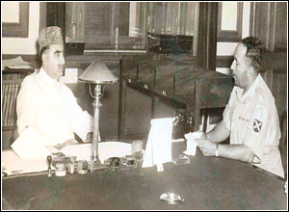
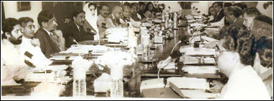
Other than the NAB, the whole of Pakistan knows the names of the corrupt officers ho ruined the name of the Civil Service of Pakistan
Today, few if any, have the pity to spare a sigh for the terminally ill civil servant. The service that once wrested awe and ungrudging respect is scarred beyond recognition. No amount of cosmetic surgery can crank up the morale of this spineless cadre baptized as the CSP. The unkindest cut comes from our present military rulers who have rendered it nameless. Gone with the wind are acronyms like CSP, CSS, DMG and OMG. The last two being deleted by Gen Naqvi, President Musharraf ‘s devolution planner.
“Some deputy commissioner must have piqued Gen Naqvi enough for the latter to deface the civil service forever,” jokes a retired federal secretary. “Mr Bhutto too hated the CSPs and tried to damage the service as much as his prime ministerial powers permitted. Still, 80-90 per cent of the federal secretaries during ZAB’s time were from the CSP cadre. That says a lot for our indispensability.”
During Ayub Khan’s ‘Decade of Development’ the CSP was its own worst enemy embroiled in ethnic rivalries. Instead of institutionalising merit and seniority, it encouraged petty provincialism and favouritism to be its driving force. Conniving godfathers from within and outside the service sprang up suddenly fanning ethnic hatred among the Punjabis, Bengalis and the Mohajirs. The Civil Service of Pakistan suffered its first major blow. Senior officers were jerked around on the basis of their ethnicity. Federal secretaries who went on leave or on a tour abroad found their offices occupied by someone else on their return. Insecurity, disillusionment and heartburn swept through the ranks. Succumbing to outside assault, the CSP was eventually swallowed up by politicians and the army.
Enter the generals who stamped their first martial law in Lahore when the government of Khawaja Nazimuddin failed to contain the Qadiani agitation in 1952. Lahore became the focal point and daily incidents of attacks on the Ahmadiyya community took place. Their houses and properties were set on fire. Soon, the trouble spread to Sialkot, Gujranwala, Sargodha and Rawalpindi.
Mumtaz Daultana was the chief minister of Punjab. He and Prime Minister Nazimuddin had open differences and it was rumoured that the law and order situation in the province was allowed to deteriorate for the army to step in and declare martial law in April 1953.
Defence secretary General Iskandar Mirza accompanied by cabinet secretary Aziz Ahmed flew into Rawalpindi one fine morning to confer with C-in-C General Ayub Khan at the Army House. According to the commissioner Rawalpindi, who was called to the meeting, General Iskandar Mirza came out with him and put his arm in the officer’s arm to lead him for a stroll in the front verandah of Army House (General Musharraf’s home today). “He (Mirza) again broached the subject saying that it was very unfortunate that the provincial government had not taken timely action and allowed the agitation to assume such an ugly turn which embarrassed the whole province and further that the situation in Lahore was still fraught with danger as mobs were persisting in law breaking despite police action.”
Next day the commissioner read in the newspapers that martial law had been imposed in Lahore and General Azam Khan, GOC Lahore, appointed as ML administrator. On that very day, Mumtaz Daultana and his cabinet were dismissed and Malik Firoz Khan Noon was named as chief minister of Punjab.
General Azam Khan got a carte blanche to interfere in the civilian affairs of the province. The CSPs were told to toe the general’s line or else draw fire from him and his army chief. The general bossed over the province with his army danda under his arm, rendering the civil bureaucracy and the politicians totally impotent. It was a sad day for the largest province of Pakistan to come under military rule just because of the feud between the prime minister and the chief minister who allowed the law and order situation to slide out of control while the bureaucracy stood by helplessly.
Why then is one surprised today when retired and serving khakis have muscled their way to top civilian posts? The transition from civil to military rule did not happen overnight. It started in early 50s. “General Musharraf is a fine man. I like him as a person. But under his governance, jobs that were the domain of the civil service have been handed over to the armed forces,” a serving bureaucrat, who asked not to be named, tells me.
This bureaucrat is a rare breed. In his living room are historic photos of past and present civil and military rulers under whom he has served in senior positions of power. Benazir Bhutto and Nawaz Sharif were famous for handpicking their IG police, the commissioner, DC, SSP and even the SP all over Pakistan. “These officers used to be in and out of the prime minister’s house all the time,” says the bureaucrat. “I never once went to the PM House and that’s why I have survived through all these governments. I was nobody’s pet.”
The bureaucrat is frank about the failings of his own tribe. He gives the example of a former chief commissioner of Islamabad who strutted about throwing his weight around. “When he retired, nobody wanted to even talk to him, leave alone sit at the same table during dinner parties. The man was arrogant to his inferiors and grovelling before his superiors.” Bureaucrats are not meant to play politics. I remember the boast of a former principal secretary who held his CSP colleagues and foreign office guys in contempt. He would always tell me that the reason for his towering success and indispensability to his boss was because he was “a politician first and a CSP officer last”.
Who are the corrupt officers? The whole of Pakistan knows their names other than the NAB (National Accountability Bureau). Starting from Ayub Khan’s time down to the present day, men who ruined the name of the Civil Service of Pakistan with their greed are recognizable from their wealth indicators.
How many homes and more importantly in which posh areas of Islamabad, Lahore and Karachi belong to the bureaucrats? Next: what are their children doing and more importantly how many of them studied abroad; how many bagged scholarships from here, there and everywhere because their daddies wangled them? Finally, where did their wives get all that money to wear diamonds, drive those luxury cars and live princesses’ lifestyles as if there was no tomorrow?

