Rule of law & civil service
By Kunwar Idris
Sunday, 24 Jan, 2010
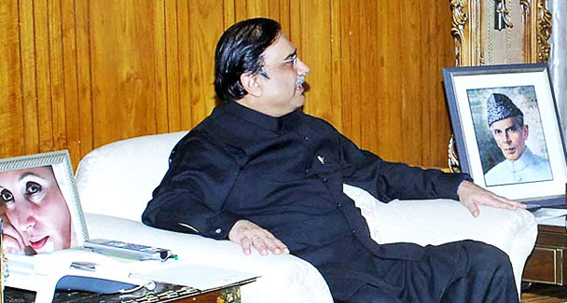
Parliamentary democracy will take root and flourish only if it is backed by a permanent civil service. If politicians must rely on party loyalists, pundits or even mobsters they better change over to the presidential system. Such was the thinking of Iskander Mirza, Ayub Khan and of Z.A. Bhutto, and so it seems of Asif Zardari. – Photo by APP.
Gen Pervez Musharraf ruled the country for three years with the help of a rump Muslim League and for another five in the presence of a quiescent parliament. Perhaps he would have still been president had he not insulted, dismissed and detained the chief justice.
A bench of 11 Supreme Court judges had legitimised his coup. The polls held three years later, in Oct 2002, were certified by an election commission headed by a retired chief justice as fair and free through all stages — the delimitation of constituencies, preparation of electoral rolls and the casting of votes.
The increase made by Musharraf in the number of general seats in the National Assembly and in the seats reserved for women and minorities was widely acclaimed. Despite this solid base of legality and popular endorsement underpinned by economic progress, Musharraf could not bring himself around to giving up his personal authority and reverting to the rule of law. Nor has President Zardari whose personal authority is, in fact, greater than Musharraf’s for he is backed by a coalition of more than two-thirds majority in parliament and is also the authoritarian chief of his own party.
As leaders contend with Musharraf’s legacy and, alongside, settle scores, they appear inclined not towards the rule of law but the consolidation of personal power and, amusingly, protocol — police escorts, ceremonial welcomes and receptions.
A constitutional settlement involving the presidency, parliament, the judiciary, the provinces and districts does not appear to be coming anytime soon. Individual egos and factional interests are in full play to delay or subvert it.
The ongoing bargaining at the constitutional plane should not have prevented the institutions and individuals at the lower planes from dealing with the problems of the people in accordance with the law and the norms of fair play. Surely, it is entirely in the power of the head of every government or office to enforce the rule of law. But they do not, and whenever they do so their actions are coloured by party affiliation or personal preference.
The Supreme Court, which had long been relying on the doctrine of state necessity and principle of salus populi suprema lex to uphold one military coup after another, has now ruled, in substance, that what is unconstitutional cannot be in the national interest and the onus of “stabilising the rule of law falls on, and must be assumed, by the executive organ of the state”.
The court’s judgment on the NRO hopefully has shut the door on the constitutionalism of convenience or necessity and points to a future in which the remedy for every deadlock must be found within the framework of the constitution.
The relationship between the president and the prime minister or the governor and the chief minister and the independence of the courts are critical issues of statecraft and will always be. However, what directly concerns the common man is how he is treated in a police station or in a court, at a revenue office, in a hospital and so on. In other words the rule of law and equity must prevail down the line even when constitutional wrangling continues at the top.
Political leaders do not seem to realise that while they indulge in power play, the public service is paralysed. The will and capacity of career civil servants is invariably impaired during the transition from military to civil rule. It is doubly impaired this time because the leaders are too many and divided.
It is politicians as a class — be they in government, the opposition or on the sidelines — who ultimately will face the wrath of the people for failing services and dwindling supplies. It is, therefore, in their interest not to interfere in the work of civil servants nor weigh their performance on the scales of loyalty to a party or an individual.
Political interference has the effect of making civil servants nostalgic about military regimes in which they enjoyed greater freedom to act under the law, and fairly.
Mr Jamsheed Marker, the world’s longest-serving ambassador and among the best in Pakistan, made a telling point in introducing his memoirs the other day. Pakistan’s career diplomats, he said, were second to none in the world and named quite a few starting with Agha Hilaly and Agha Shahi, Iqbal Akhund and my friends Mansur Ahmad, Shaharyar Khan and later Munir Akram.
It is a measure of their diplomatic skill that Pakistan’s resident ambassador at the UN has been elected to chair the Security Council more times than many larger and richer countries.
The lateral, i.e. political, inductions detract from that image but the Foreign Service was able to withstand the stress of lateral entry much better than the home civil service which, in addition, was broken into pieces.
Having lost their moorings the civil servants as a class, or at least most among them, sought shelter in the safer haven of politics to remain in the mainstream of administration and earn promotions. That became the attitude of every professional cadre. Today most civil servants are believed to be aligned with one party or the other, liked by one politician and loathed by another.
Generations of Pakistani politicians have increasingly revelled in a nominated, weak and compliant civil service little realising that they were constantly paving the way for martial law — one after another. Parliamentary democracy will take root and flourish only if it is backed by a permanent civil service as Westminster is by Whitehall. If they must rely on party loyalists, pundits or even mobsters they better change over to the presidential system. Such was the thinking of Iskander Mirza, Ayub Khan and of Z.A. Bhutto, and so it seems of Asif Zardari.
The argument that must clinch the issue, however, is that democracy without the rule of law means nothing more than desultory debates in parliament, in the media and daily harangues of political leaders. And for the rule of law a neutral civil service is a prerequisite no less than an independent judiciary.

