Indifferent to children
By Anees Jillani
Tuesday, 07 Jul, 2009 | 09:05 AM PST |
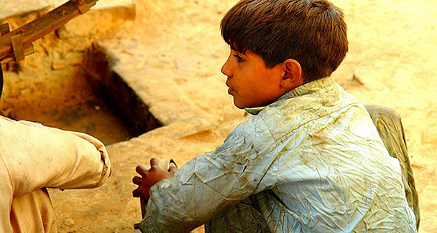
The UN convention on child rights continues to lack the force of law in Pakistan. — File Photo

Pakistan
Financial crisis may push more children into labour force

IN 1989, the UN presented to the world community the Convention on the Rights of the Child containing all possible rights that may relate to children. A world summit was planned in 1990 to convince the UN members to sign it. Pakistan became co-host.

In the midst of this excitement to act as co-host, the country signed, and later ratified the convention in November 1990. It is an altogether different matter that we have failed to achieve much in this context.

Monitoring compliance with the convention is done by an 18-member committee which sits in Geneva thrice a year. Parties to the convention must file their initial report within two years of the ratification, and then every five years.

Pakistan submitted its initial report almost on time, but took nine years to submit the next one. The report was considered at a meeting in April 1994. The committee asked Pakistan to furnish it with a progress report by 1996 but this was not done. The second report was due by 1997 but it was not filed until 2002. It was reviewed by the committee and adopted on Oct 3, 2003.

By the time the Committee took up the second report, the date for filing the third one had passed, and Pakistan was asked to consolidate its third and fourth reports and file them by 2007. Even this was filed late and is to come up for consideration by the committee on Sept 28 this year.

The committee is overworked, and has formulated a strategy to partly overcome this. It holds a pre-session working group where interested NGOs can present their critique of the report and give supplementary and alternative information. Such a working group met to consider Pakistan’s report in Geneva on June 17. I presented to the committee what is sometimes called an alternative report. The committee came up with a list of issues which has already been presented to the government that must respond by Aug 3.

It is obvious that Pakistan’s compliance with the convention leaves lot to be desired. A simple review of the committee’s concluding observations given in 1994 and 2003 shows that we have failed to comply with most of the recommendations. The committee, while issuing its concluding observations, has repeatedly asked Pakistan to follow the guidelines while preparing its report, but the government fails to do so. The convention expects a state party to introduce an institutional mechanism for implementing it.

The National Commission for Child Welfare & Development (NCCWD)), a small unit within the social welfare ministry, entrusted with the responsibility of preparing these reports, hires a consultant to draft these reports, instead of opting for institutionalisation. What can NCCWD expected to achieve with a meagre budget of Rs2.8m a year in a country with a population of more than 70 million children?

The committee had recommended that the second report and its concluding observations should be made available to the public in English and local languages. This was not done. The level of awareness about the convention is low. A few seminars or workshops can hardly be expected to make a difference in a country of 165 million. A systematic and sustained approach is required to achieve this goal. The use of the media can be effective but is absent at the moment.

It is nothing short of shocking that the convention continues to lack the force of law in Pakistan. Few child-specific laws have been introduced. Only one law relating to child labour, i.e. the Employment of Children Act 1991 has been enacted since 1990 although its schedule was modified in December 2005, expanding its coverage, which has been a welcome development. Another positive development is Pakistan’s ratification of the Minimum Age Convention (No 138), since July 6, 2007; and the Worst Forms of Child Labour Convention (No 182) in January 2001.

In the year 2000, the Juvenile Justice System Ordinance was adopted which has perhaps been the sole legislation prepared to bring about a law to conform to the convention. However, the age of criminal responsibility remains at seven years under the Pakistan Penal Code 1860.

Two sets of child rights laws were introduced in Punjab in 1952 and 1983. They were never enforced. In 2004, the Punjab Destitute & Neglected Children Act was passed, which has so far been only used to operate a street children’s centre in Lahore. The Sindh Children Act has been on the statute books since 1955. However, no major steps have been taken to implement it. In Karachi, an Industrial School for Youthful Offenders is operating under this law. It is basically a juvenile prison. No courts have been established under it, although the law provides for such a possibility.

No laws exclusively relating to child rights exist in Balochistan and the NWFP or Fata, Pata, the Northern Areas and Azad Kashmir. Laws making education compulsory up to the fifth grade have been introduced in most places except Balochistan, the Northern Areas and Azad Kashmir, but no steps have been taken to enforce these.

Authorities meant to enforce these laws have not been formed despite the passage of more than a decade in some cases; and rules have yet to be introduced. A Child Protection Authority bill in Sindh and the Frontier and the Protection of Children bill at the federal level remain pending for years now.

Unfortunately, we have been only talking about plans of action and policies since independence. Such action plans and policies have never been able to make a difference to the children of Pakistan for the simple reason that they have no validity under the law, and their status remains confined to a piece of paper.

The writer presented the Alternative Report to the Committee on the Rights of the Child.
aj@jillani.org

