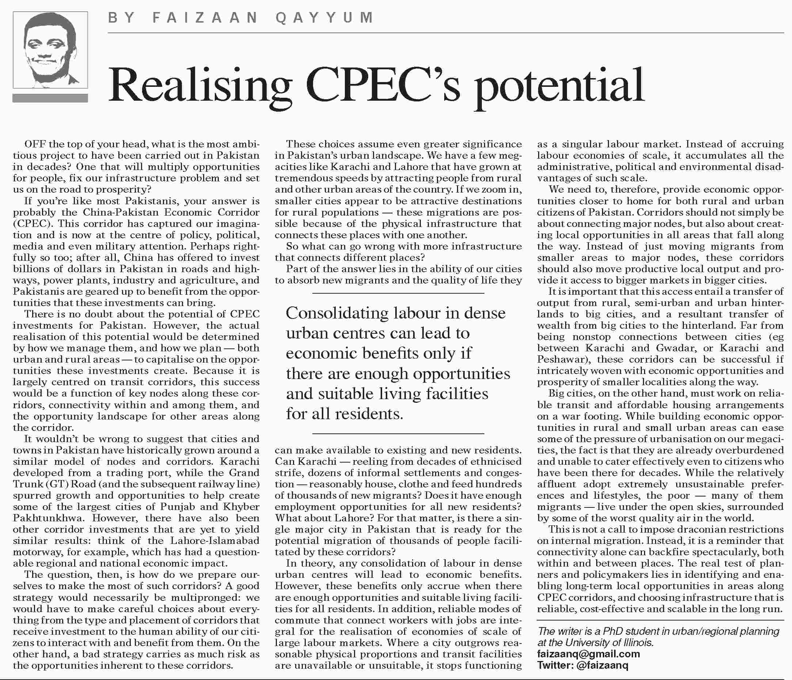
[TOP]

More from this page
- Noisy parliament
- Venezuela turmoil
- An ever-widening dragnet
- The painful truth

