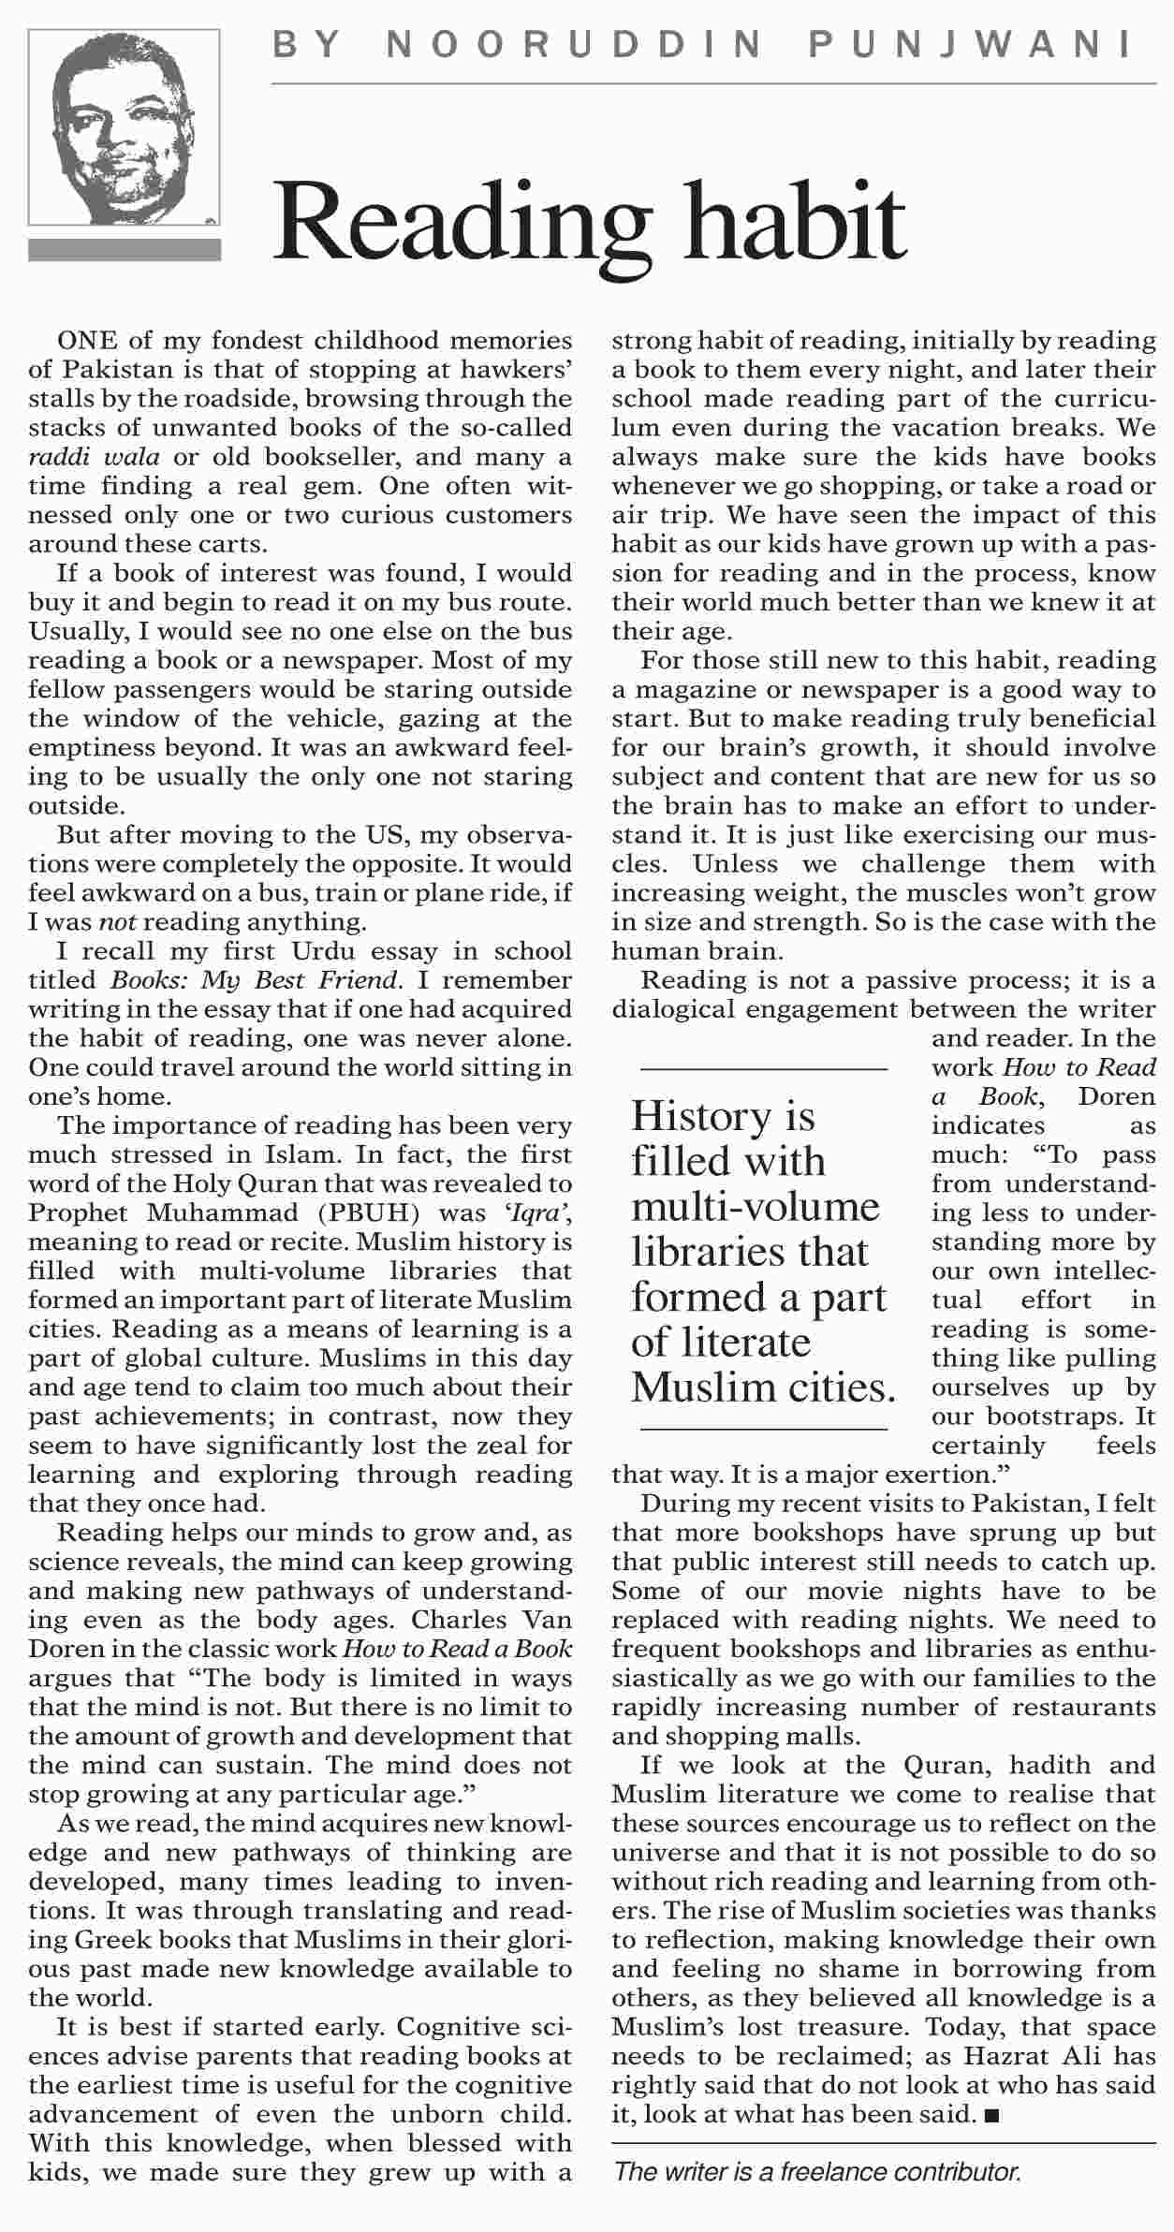
[TOP]

More from this page
- Beyond the bubble
- Bhutto`s echoes in NA
- Afghan peace
- SBP ad

