Nothing but the truth
By Niilofur Farrukh
Tuesday, 18 Aug, 2009 | 08:17 AM PST |
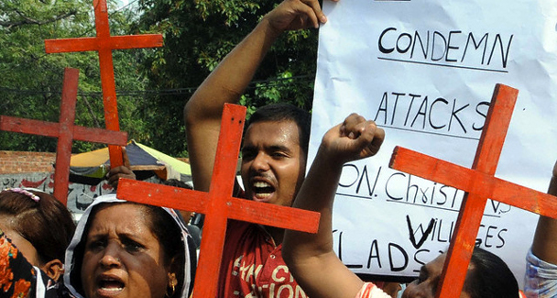
There is substantial evidence that the blasphemy law has been used to fuel religious extremism. — File Photo

Pakistan
Time to repeal the law

Someone recently reminded me that poet-philosopher Rumi believed the truth to be the noor (light) of God and perceived it as spiritual energy with the power to communicate and heal. Every sage and belief system has placed morality at the core of all that is the finest in the human DNA.
While we often articulate the desire to tell the truth, in reality the truth seems to be getting lost in spin and a partial truth has insidiously become integral to our lives. Perhaps it’s because we have forgotten that half-truths are actually half-lies. New terms such as ‘misinformation’ and ‘de-briefing’ have been coined to further the distance between facts and their recipients.
When leaders speak the truth, nations rally behind them and work miracles. Churchill laid out the perils of war in front of his nation and the people of the tiny island rose to the challenge. It was neither sugar-coated lies nor the illusion of victory but harsh facts told with honesty and sincerity that compelled people to unite behind a leader who led by example, not rhetoric.
A nation faced with constant deception learns to read the gap between empty words and reality that creates an acute trust deficit. This loss of faith deepens cynicism and disillusionment among citizens and can retard the democratic process. New behavioural patterns and social norms spawned by corruption and blind personal ambitions have little or no space for the truth. ‘Just don’t get caught with your hand in the cookie jar’ is the guiding refrain for the upwardly mobile corporate pack and politicians alike. If you do get caught then there is always the NRO and ‘no-need-to-return-your bank-loan schemes’ for the political elite.
The absence of practices of integrity in public and private life has had a deeper impact than we care to admit. The judicial system suffers as witnesses withdraw from giving evidence either out of fear or pressure to lie under oath. The tensions that manifest themselves in uncertainty and riots causing large-scale damage, fear and anger find their roots in injustice and deprivation.
If Pakistan had an upright system and leaders that did not prioritise political expediency over human suffering after Shantinagar in 1997, when arsonists set fire to 13 churches and 700 homes, making scores of Pakistani Christian families destitute, the blasphemy law would have been long repealed. There is enough evidence that this law has been repeatedly used to fuel religious extremism and settle personal scores.
Early evidence collected by the Human Rights Commission of Pakistan at Gojra points not to desecration but blatant lies used to whip up mob frenzy which as the late Eqbal Ahmad rightly pointed out in his article, A town called Shantinagar (1997), exists because of ‘demagogues who ply ideologies of differences and sell faith as hate and fear’.
Twelve years later nothing has changed — the Gojra inferno took seven lives and the mob and callous lawmakers must share the blame equally. The nation is once again forced to ask why it is that the government can never offer more than band-aid solutions and empty words in a crisis. What prevents it from formulating preventive policies?
An honest effort to bring long-term peace to Gojra could start with strategies of the truth and reconciliation commissions where the instigators must publicly confess to their guilt and victims narrate their harrowing experience. In this case, the fact that the incident that triggered the riots was erroneously reported necessitates that those involved, from rumour-mongers to those persons who used the sacred precincts of the mosque to incite people, confess how and why they responded to mere hearsay and committed murder and arson.
Another deterrent would be to levy fines on the guilty to help rehabilitate the victims. Why should the crime of a few be a burden on the national exchequer? The guilty Muslims of Gojra must contribute in kind and cash to resettle their Christian neighbours.
When the truth is confessed by the guilty and is accompanied by an apology, remorse and repentance, it leads to healing — trust is rebuilt and faith in human goodness restored. Truth and reconciliation commissions across the world bring together victims of atrocities and their perpetrators. These commissions have seen the triumph of truth as sincere confessions, and have the uncanny power to communicate, convince and build bridges.
If Pakistan is not ready for such cathartic confessions, then there is all the more reason for some serious introspection on how to restore morality both to the public and private sphere.
Ghamdi sahib, the reformist religious scholar, has frequently emphasised the need for ethics and morality in primary education before religious teachings are introduced in the curriculum. He believes religious reform is only possible if people are aware of the context in which to interpret religious injunctions.
With each Gojra and Shantinagar, the fabric of society is irreversibly damaged by bigotry and corruption and the need for a corrective mechanism to create an environment of trust and transparency acquires greater urgency.

