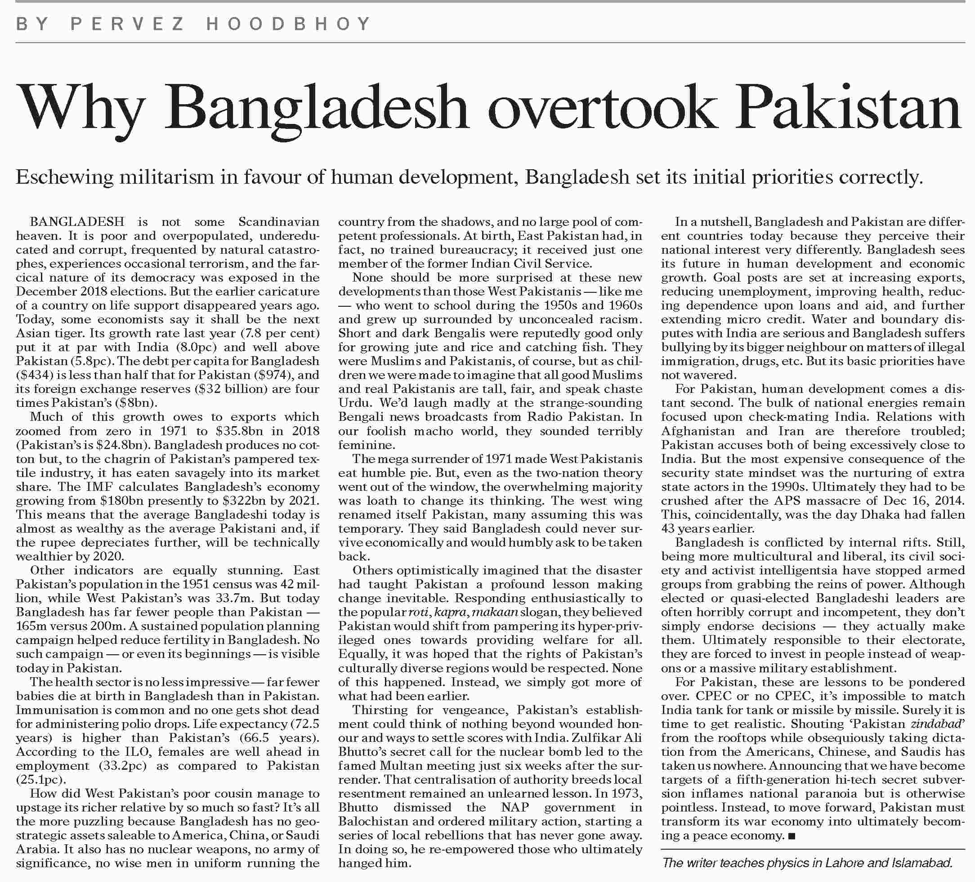
[TOP]

More from this page
- Reluctance to talk
- Detained activists
- Gas crisis
- Way out of a broken system

