New chapter for India & BD
By Kuldip Nayar
Friday, 05 Feb, 2010
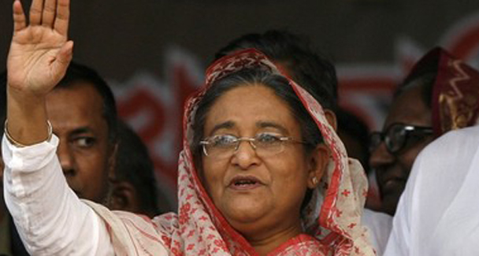
Sheikh Hasina’s style of governance has a touch of authoritarianism. Indira Gandhi had the same trait.
All eyes in Bangladesh are focused on New Delhi to see if and when it begins to implement the steps listed in the joint communiqué that the prime ministers of the two countries signed last month.
Since independence Bangladesh has been unhappy with the violation of promises. Talking to people in various fields, I found that the response to the joint communiqué was jubilant. One editor commented: “Bangladesh has put all its trust in India and if relations between the two countries get clouded, it would be India’s doing.”
Bangladeshis were willing to give six months for the assurances to fructify. The disillusionment will begin if the Indian bureaucracy sits on the files. Positive feelings may give way to a negative mood. Fundamentalism which has been defeated by Prime Minister Sheikh Hasina Wajed who fought and won the polls on the plank of pluralism may reappear.Water is the litmus test.

Before Sheikh Hasina’s visit, Bangladesh expected India to be generous enough to give an undertaking that it would not touch any river flowing into Bangladesh without its consent. Now the expectation has come down to the assumption that the river Teesta will not have any dam, barrage or the likes which may lessen water for Bangladesh in any way.
The joint communiqué is not so categorical because it only says that the discussions on sharing Teesta waters between India and Bangladesh should be “concluded expeditiously”. The joint river commission is scheduled to meet in March after a lapse of seven years.
Prime Minister Manmohan Singh’s assurance that India would not take steps on the Tiparmukh project that would adversely impact Bangladesh should have been adequate. He has even allowed a parliamentary team from Bangladesh to visit the dam. Yet I found people apprehensive.
Commerce is another sore point with Bangladesh. The balance is substantially in India’s favour. If unofficial trade is counted, the deficits may well be around $6bn. True, New Delhi has removed tariffs on all except 47 items. But the earnings from them may not be more than $10m to $15m. Had India allowed zero-tariff access to whatever is manufactured in Bangladesh it would have been a gesture which could have dented even the hard opposition lobby.
No doubt, Sheikh Hasina has shown courage in accepting something which should have been done long ago: facilitating India’s access to the Mongola and Chittagong seaports. The fallout in the shape of trade will benefit Bangladesh. India will have a shorter and quicker way to reach the northeastern states. In exchange, Bangladesh has got access to Nepal and Bhutan. In fact, both Nepal and Bhutan have been wanting free contact with Bangladesh but New Delhi was dragging its feet.
We owe our gratitude to Bangladesh, particularly to Sheikh Hasina who said in the joint communiqué that she would not allow her soil to be used by terrorists. Compare it to what Pakistan Prime Minister Yousuf Raza Gilani said: how could Islamabad assure India that Pakistani soil would not be used against it? She has handed over United Liberation Front of Asom leaders operating from Bangladesh. In contrast, Islamabad has indicated that it cannot hand over any of a number of offenders in Pakistan who have committed crimes in India.
However, the Bangladeshis have not forgiven India for some 400-odd people killed on the border some time back. India’s Border Security Force was reportedly checking the infiltration. Should there be firing straightaway on the nationals of a friendly country? The killing of so many people smacks of uncontrolled anger. On the other hand, Bangladesh should realise that nearly 20 million of its nationals are living in India illegally. Assam has been affected the most.
Had India agreed to issue work permits to Bangladeshis, the infiltration would have come down drastically. They come to India to work and earn money for their families back home. They do not want to settle in India. The proposal to build flyovers in Dhaka is practical. The joint communiqué mentions the possibility. Traffic is bad enough in Delhi, Mumbai or Kolkata. But it is worse in Dhaka where it takes hours to go from one point to another.
I have seen the birth of Bangladesh and its steady growth. When it parted company with West Pakistan, not many people bet on Bangladesh. Today, after nearly four decades of independence, not many people are pessimistic. Remittances from Bangladeshis working abroad and earnings from the garment industry have given Bangladesh an annual growth rate of a little more than five per cent. Small farmers have made the countryside more or less self-sufficient.
True, the Bangladeshis are still unsure of themselves. They are yet to reconcile themselves to the fact that theirs is a small country with limited resources. Yet their fortitude is impressive. But what is dejecting is the increasing concentration of power at the prime minister’s level. That Bangladesh is a unitary polity goes without saying. However, if real power and funds could be transmitted to the local bodies, the off-and-on democracy in Bangladesh could acquire depth.
India should feel encouraged that another democratic, pluralistic country is taking root in the region. In Bangladesh the liberal world has a nation which has waded through a pool of blood to stay independent and democratic. A liberal, democratic Islamic state is something which may show the way to the entire Muslim world.
Sheikh Hasina’s style of governance has a touch of authoritarianism. Mrs Indira Gandhi had the same trait and India had to pay the price during the two-year-rule of emergency. At times, the Bangladeshi prime minister appears too impatient, too impressionable and too impetuous. She has only herself to fear, not the hapless opposition.

