Motherland for sale?
By I.A. Rehman
Thursday, 10 Sep, 2009 | 01:58 AM PST
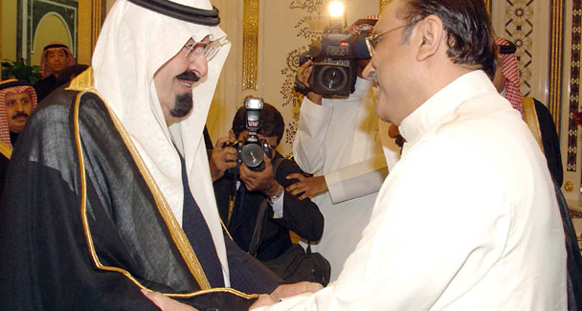
It is in Pakistan’s supreme interest, and perhaps in Saudi Arabia’s interest too, to further develop their meaningful and mutually rewarding collaboration in all possible areas. —AFP/File Photo
THE report about a possible leasing out of half a million acres of land to foreign parties has not caused the kind of outrage it should have. Perhaps this is more proof of the ostrich-like habits of Pakistanis. The agency report carried by the media about a week ago was unambiguous and categorical.
Government officials were quoted as saying that talks with Saudi Arabia had been going on for several weeks and that Pakistani authorities were locating pieces of land in all the four provinces to be leased. A Saudi delegation was expected after Ramazan to finalise the deal and inspect the land offered on lease.
The report also recalled an earlier government statement to the effect that foreign investors were going to be offered a million acres of farmland for lease or sale and that it would deploy special security forces to protect the lessees.
Obviously the outlandish project for corporate farming drawn up by Gen Musharraf’s whizz kids in 2007 has been adopted by the present, supposedly people-friendly, government. However, the interest of both Pakistan and Saudi Arabia demands that before matters proceed any further the proposed deal be dispassionately scrutinised. This plea is backed by many forceful arguments.
True, Pakistan has been selling its family silver for quite some time. But land is not ordinary property that can be summarily disposed of. Apart from the fact that for the peasants land is mother earth, madari-i-watan or dharti mata, it is an essential attribute of nationhood/statehood. No possessions or riches can entitle a people to call themselves a nation or to establish a state if they do not have land. Alienation of land is thus not as simple a matter as renting out a house to a foreign diplomat. For that reason, the UN General Assembly resolution on Permanent Sovereignty over Natural Resources says:
‘The right of peoples and nations to permanent sovereignty over their natural wealth and resources must be exercised in the interest of their national development and the well-being of the people of the state concerned.
‘The exploration, development and disposition of such resources, as well as the import of the foreign capital required for these purposes, should be in conformity with the rules and conditions which the peoples and nations freely consider to be necessary or desirable with regard to the authorisation, restriction or prohibition of such activities.…’
This plainly means that all peoples have a fundamental right to land and that its disposal in favour of foreign investors does not fall within the routine functions of the government; it can only be decided by the people, through parliament and other representative institutions.
All conscious and responsible societies sanction only three uses of land. Firstly, it must be used in the economic interest of the people, which means raising the farm output to the maximum so that food security is guaranteed and the national kitty enriched. Secondly, a rational land utilisation pattern should meet the social needs of the people by offering the tillers of the soil the means of subsistence. Thirdly, and perhaps most importantly, ownership of land empowers the people.
In a country where land hunger is acute and hundreds of thousands of skilled cultivators have no land or are without subsistence-level holdings, the giving away of land to foreign parties or non-farming institutions or retired civil and military employees for that matter, should be considered a criminal denial of the people’s rights and their interest.
The government itself is a lessee as all land belongs to God, according to the Islamic faith, or to the state (not government), according to the official theory in Pakistan. Both restrict the government’s power to lease/sell land. Besides landless peasants have the first right on any land that is at the government’s disposal.
It is also necessary to take into consideration four unavoidable consequences of leasing land to foreign investors.
Firstly, if land already under cultivation is leased out, all those working on it, haris and field workers, face the threat of unemployment. Secondly, we have learnt from the experience of the mustajiri system (whereby commercial entrepreneurs acquire big farms on lease) that the contractors, in their drive to maximise profits, exploit the land so ruthlessly that it loses fertility and becomes weak and sick.
Thirdly, land lease arrangements can lead to the unconscionable exploitation of physical and human resources, such as that seen in the working of timber and mining mafias in Latin America. Finally, lessees of land acquire considerable political clout that undermines the capacity of the lesser-states to uphold their national interests.
Islamabad should also realise that the proposed deal could undermine its relations with Saudi Arabia. Issues are bound to arise regarding the cropping pattern on the leased land, water supplies, the terms of employment offered to Pakistani labour, the privileges of foreign personnel working on the farms and security arrangements that might put the traditional friendship between Pakistan and Saudi Arabia under strain.
Saudi Arabia is one of Pakistan’s most valuable friends. The people of Pakistan cannot forget the huge debt they owe to the Saudis. It is in Pakistan’s supreme interest, and perhaps in Saudi Arabia’s interest too, to further develop their meaningful and mutually rewarding collaboration in all possible areas. Leasing out Pakistani land to Saudi investors could threaten a basic assumption of our foreign policy.
No doubt, Pakistan must try to help its friends in the Middle East and the Gulf region overcome their requirements of agricultural produce and livestock. Thus, it should not only achieve food autarky but also generate surpluses so that it can supply its friends on the eastern side with food items, maybe at rebated rates.
This is a theme fit for discussion at the Organisation of the Islamic Conference (OIC). An OIC project for financial aid to Muslim countries with potential for higher farm outputs to be used by the recipient countries through their own human resources will be a more effective and less painful way to meet friendly countries’ food requirements

