Leasing land to foreigners losing lustre
By Aftab Ahmad
Monday, 08 Feb, 2010
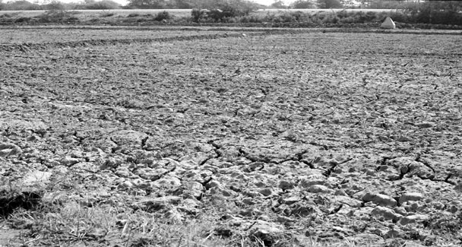
ABOUT a year ago, there was an uproar in the media about the government’s plan to lease thousands of acres of uncultivated land to Saudi Arabia and the UAE in exchange of returns that could benefit the agriculture sector and the economy as a whole. The protests died down in the subsequent months but some lone voices are still heard , from time to time,. opposing foreign investment in farming.
The news reports appearing on January 28 quoted foreign minister Shah Mehmood Qureshi, saying in Dubai that the government would encourage investment in the agriculture sector, adding that such an investment would be of immense help in alleviating poverty, by providing employment to the jobless in the rural sector. He however assured that only such land would be leased which is not in use.
An article published in the Business Week in the first week of December 2009 under the caption ‘Land rush in Africa’, however, suggests that the experience did not prove a success in Africa, as local farmers were not happy with the foreign investors. In fact, they considered the corporate farmers as ‘new colonialists’.
According to the report, agribusinesses in the US were leasing vast tracts of African lands from which they expected to earn money by exporting food grown on those farms. At the same time, the oil-producing countries in the Arab world were reported to be in quest of fertile lands around the world, to boost their food security..
In Kenya, small farmers and cattle owners complained that they were being displaced without compensation. According to local residents, the investors had not offered as many jobs as they claimed, during the six years since they arrived. Villagers, also, accused the investors of polluting water and held them responsible for the sickness of their farm animals.
A number of new developments were reported to be behind the rush to invest in farmland in Africa. Higher oil prices in 2007/2008 had pushed up the cost of agricultural production and shipping. Besides, rise in food prices because of a severe drought in Eastern Europe and Australia had created an opportunity for agribusinesses to buy cheaper agricultural land. Investors and corporate farmers thus rushed to acquire farmland in Kenya, Sudan, Tanzania and Ethiopia. Governments in these countries, which usually depend on global food aid, readily leased land to outsiders in exchange for promises of cash, roads and schools. Local residents were, however, not consulted which resulted in resentment from them later.
According to the report, Japan, China and some other Asian countries had been operating farms in Africa for more than 20 years. As per United Nations reports, about a million Chinese are engaged in agricultural work in Africa. Of course, they are being followed by others. Recently, Saudi Arabia is reported to have held a ceremony in Riyadh to celebrate its first harvest from some $100 million rice and wheat farms in Ethiopia. Now, Qatar is also reported to be joining the race. The Middle East Emirate, it is understood, would build a port in the coastal city of Lamu in Kenya, in exchange for a long-term lease of nearly 100,000 acres, for growing rice.
Local population in Kenya disputes the claim of foreign investors about providing employment to as many as 700 people. Villagers say that the company had hired some 200 people in 2007 to pull weeds and chase away birds. However, as the farm became more mechanised, the number of workers was reduced. Besides, the wages being paid were quite low. A number of women workers, when interviewed, informed that they earned less than 200 shillings a day – equivalent to $3.
When the agricultural crops of some Kenyan farmers were destroyed in 2007 due to heavy downpours and floods, they blamed it on a dam built by a foreign company for irrigation purposes. More than 1000 homes were damaged. Local residents also complained that since the arrival of foreigners, drinking water from the Yala River has developed a metallic taste, which was attributed to the company’s use of fertilisers. Besides, spraying pesticides had made many farm animals sick. According to local farmers, nearly every home had a dead cow or a dead goat.
A soil and water analysis undertaken in August 2009 (financed by the anti-poverty group Action Aid International) reached the conclusion that people should not drink from the Yala River. The analysis had suspected the presence in the river-water of dialderin, a chemical ingredient in some pesticides that has been linked to breast cancer and Parkinson’s disease.
The question arises as to why there was such a rush for farmland in Africa. In all probability, it was because land was available there in abundance, at throw-away prices. Neither the governments nor the people living in the African countries had enough money to spend on seeds, fertilisers, pesticides and tractors etc, in order to bring the vast areas under cultivation.
Governments in those countries were always ready to lease agricultural land to foreigners in exchange for cash and commitment to build roads and schools etc. On their part, investors were also happy because they got the lease in exchange for nominal returns and they expected to earn maximum profits from the deal. Moreover, labour in Africa is also cheap, which helps investors in keeping the costs at low.
Pakistan has not so far been able to attract foreign investment into its agriculture sector, despite the government’s eagerness to do so. There could be many reasons for it. First, security concerns resulting from terrorists activities have kept foreign investors at a distance. Second, continuing energy crisis and shortage of irrigation water constitute a hurdle in making any long-term investment in the sector. Third, due to the country’s record of frequent changes in the policies, foreign investors may be cautious in making any long-term investment in the sector. Last but not the least; the investing countries are aware that agricultural land would not be available at throw-away prices as it is in Africa.
However, the government should take all the aspects of the case into consideration before entering into an agreement, in order to avoid opposition from local residents and others, in the light of experience in Africa. Besides, instead of putting emphasis on the payment of the entire price in cash, the government should persuade the investing country to help in power generation or construction of a dam in the country. Also, the government may require the investor to sell 20-25 per cent of its produce to the government to help it in building strategic food reserves so as to fight a possible food shortage within the country.

