Will meetings solve the Afghan problem?
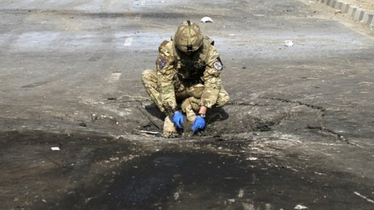As long as US policy on withdrawal and talks with the Taliban remain inconclusive, the violence will continue
Continue reading the main story

Taliban Conflict
- US patience wears thin
- Taliban tactical shift
- Haqqani militant network
- Q&A: Fighting the Taliban
Until real progress is made in US-Taliban talks and Pakistan shows that it is serious about peace for its neighbour, new conferences on Afghanistan's future will achieve nothing, guest columnist Ahmed Rashid argues.
With one major international conference on Afghanistan having yielded few results, and another due in December, Afghanistan - its relations with its neighbours, US policy and the troop withdrawal, talks with the Taliban - remains on the brink of uncertainty.
A divided US administration, a rejectionist Iran, a stubborn but crumbling Pakistan and growing divisions within the Afghan polity, as well as the major Taliban groups, have all created a crisis where there is a desperate need for a breakthrough before the Bonn conference on 5 December.
The regional conference in Istanbul on 2 November was supposed to bring Afghanistan's neighbours together to agree a pact of non-interference in Afghanistan's internal affairs and a mechanism through which such a pledge could be monitored.
Instead we saw that conference turn into an "Istanbul process" with the promise of more meetings to be held on the subject and a pledge of non-interference - similar to the one given by the neighbours in 2002 and never adhered to - but no means for the Afghans, the UN or anyone else to monitor such a pledge.
That will now be discussed in future endless meetings of the so-called "Istanbul process."
Troop timetable
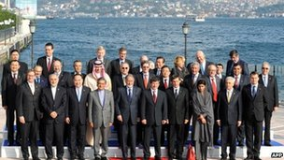What did they achieve? Delegates from the conference on Afghanistan in Istanbul pose for the cameras
One of the causes of failure has been the US doing inadequate homework. None of Afghanistan's neighbours will commit to anything until they know what the forthcoming US-Afghanistan Strategic Pact will hold - how many US troops and/or bases will be left behind after the bulk of US and Nato troops leave in 2014.
All the neighbouring countries are against such a long-term US military presence in the region, but before they set down their intentions, they want to see what the US presence will look like.
And President Barack Obama recently threw a new spanner in the works, saying the bulk of US troops may be pulled out by the end of 2012 just before his re-election bid - which has dismayed many Afghans.
With nobody in the region knowing what US intentions are, consequently Pakistan, Iran and Russia all had objections to the idea of a monitoring mechanism, angering the Afghans who fear that their neighbours will interfere again just as they did in the 1990s.
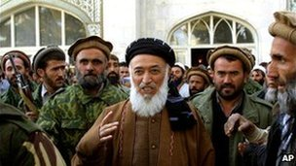Burhanuddin Rabbani was assassinated despite ongoing peace talks with the Taliban
Moreover, the Istanbul meeting could have generated more regional confidence if talks between the US and the Taliban had progressed further than they have done.
The only positive outcome was that for the first time India and Pakistan tolerated each other at a regional conference on Afghanistan. Pakistan's ever worsening relations with the US now dominate the future Afghanistan scenario.
During last month's visit of US Secretary of State Hillary Clinton to Islamabad, Pakistan's military is reported to have offered to broker talks between the US and the Taliban - with Pakistan at the table.
However, the Americans are doubtful if Pakistan can deliver either the main Taliban, called the Quetta Shura or even the Haqqani network. In August, a secret US-Haqqani group meeting with Pakistani intelligence at the table only led a month later to the Haqqani group attacking the US embassy in Kabul, angering the Americans.
Pakistan's instability
The Taliban leaders have lived in Pakistan for 11 years, so there is no reason to doubt that the the Pakistani intelligence service ISI cannot deliver them for talks when it wants to. Yet the Afghan government, the Taliban and the US are increasingly mistrustful of the Pakistani military.
There is nobody else to talk to as the civilian government led by President Asif Ali Zardari has opted out of all decision-making on Afghanistan and left it in the hands of the military.
Meanwhile, the military's obsession with Afghanistan is undermining the country's overall foreign policy as it becomes increasingly isolated internationally. The obsession is also undermining domestic stability because key issues such as the economy are being ignored.
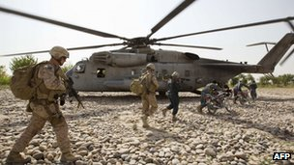Afghanistan's neighbours are keen to know how many US troops and bases will be left after withdrawal
Pakistan needs to say and do something more if it wants to generate more goodwill and demonstrate its seriousness of purpose for peace.
It could demand more publicly that the Taliban enter into talks, give a deadline for Taliban leaders to move out of Pakistan, or free Taliban leaders in jail for negotiating with the Afghan government without the military's permission.
On the other hand, Washington and Kabul cannot just ask favours from Pakistan without finding a way to bring Islamabad into the dialogue with the Taliban.
The dialogue process started earlier this year between the Americans and the Taliban, with the help of German and Qatari mediators, is continuing, despite the shocking assassination of Burhanuddin Rabbani, the head of the Afghan government's negotiating body.
The Taliban have denied that they killed Rabbani and there is still no clear indication as to who was responsible. The motive was to try and disrupt the dialogue process but that it has not done.
The US-Taliban talks are still at the level of trust-building rather than actual negotiations, but much-delayed progress in this process of confidence-building depends on whether there can be a public Taliban commitment to enter into peace talks and the creation of a Taliban office in Doha, for which Qatar has given the go-ahead.
Such steps need to be taken before the Bonn conference where 90 countries will gather. Bonn must provide a breakthrough, with the US clearly declaring its intentions in Afghanistan, the world committing to help Afghanistan beyond 2014, and a public declaration of peace talks by the Taliban and the Americans.
Otherwise Bonn will be one more wasted conference.
Ahmed Rashid's book, Taliban, was updated and reissued recently on the 10th anniversary of its publication. His latest book is Descent into Chaos - The US and the Disaster in Pakistan, Afghanistan and Central Asia.

