The Durand Line
By A.G. Noorani
Saturday, 26 Dec, 2009
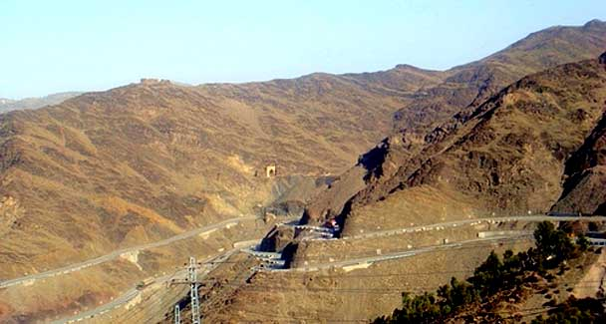
A view of the Peshawar-Torkham highway.
As the tragedies in Afghanistan unfolded since 1974, deserved empathy for its plight was extended by some to sympathy for its claim to Pakhtunistan.
The record of boundary-making and Afghanistan’s unprincipled behaviour were overlooked. The Durand Line was not an imperial diktat but a fair compromise as impartial authorities acknowledge.
John Griffiths recounted in his book Afghanistan (1967) “an amiable, lengthy and courteous interview” with its prime minister. But he “sparked a flash of anger when I asked him whether he thought any part of Afghanistan should become part of [Pakhtunistan]. His sharp ‘never’ and subsequent rebuke of my ‘irrelevant’ question betrayed, not only strength of feeling, but perhaps also an awareness of the ambiguity and weakness of the arguments for an independent [Pakhtunistan]”.
It is sheer territorial aggrandisement, not a case of self-determination. In January 1960 Pakistani Foreign Minister Manzur Qadri baffled his Afghan counterpart, Mohammed Naim with a proposal for a plebiscite of the Pakhtuns in Afghanistan since those in Pakistan had already voted in a referendum on July 17, 1947. As two-thirds of them lived in Pakistan, it was more rational for the rest to join the majority. Manzur Qadir repeated the offer publicly on March 7, 1960.
The Durand Line was not drawn arbitrarily. It was defined in a brief agreement signed in Kabul on Nov 12, 1893 by India’s foreign secretary, Sir Mortimer Durand, and King Abdur Rahman Khan, in the text and the attached map. J.V. Prescott an authority remarked on “the spirit of compromise in these negotiations” which was reflected in the concession Durand made; notably on the Chagai area”.
Demarcation on the ground began in April 1894 and was completed in May 1896. During this period seven sections of the boundary were precisely defined in agreed documents — to wit, on Nov 21, 1894; Feb 26, 1895, March 8, 1895, April 9, 1895, April 15, 1895 and May 13, 1896.
Only two sections remained un-surveyed. Amanullah Khan’s jihad on the firangis accomplished that. He hoped to acquire Peshawar and areas in the Derajat up to the Indus. The peace treaty signed in Rawalpindi on Aug 8, 1919, confirmed the frontier “accepted by the late ameer” and provided for an “early demarcation” of the “undemarcated portion of the West Khyber where the Afghan aggression happened”.
The treaty of Nov 22, 1921 signed at Kabul, confirmed the Rawalpindi treaty and “also the boundary west of the Khyber” laid down by the commission in August-September 1919. By an exchange of notes on Feb 3, 1934, the parties confirmed their agreement of July 11, 1932 on the frontier “in the neighbourhood of Arnawai and Dokalim”. A process that began in 1893 ended 40 years later in 1934.
A note came on June 13, 1947 after Mountbatten’s announcement of the partition plan on June 3, 1947 to overturn all that. Afghanistan now demanded that the terms of reference of the referendum in the NWFP under the plan should be widened to cover independence or accession to Afghanistan. London rejected the demand asserting its rights under the treaty of 1921 and denying “the right of a foreign government to intervene in the internal affairs of those areas”.
At a meeting of the Indian cabinet on July 4, 1947 at which Jawaharlal Nehru and Liaquat Ali Khan were present, Nehru, as minister for external affairs, said, to quote the minutes, “about a month ago the press and the radio in Afghanistan had started a campaign giving prominence to Afghanistan’s interests in the North West Frontier and the claim was made that Pathans were Afghans rather than Indians and they should have the utmost freedom to decide their own future and should not be debarred, as the proposed referendum would appear to do, from deciding either to form a separate free state or to rejoin their motherland, viz Afghanistan.
These claims had later been taken up on an official level with HMG and the Government of India. The Government of India had refuted this irredentist claim of Afghanistan to the area lying between the Durand Line and the Indus river, and had pointed out that the issue regarding an independent Pathan state was a matter entirely for the Government of India and the Afghan government had no locus standi. HMG’s minister at Kabul had mentioned the possibility that the Afghan government’s object might be to divert public attention in Afghanistan from the internal economic situation which was precarious.”
On July 5 Britain handed the Afghan charge d’ affaires an aide-memoire rejecting demands in respect of “an area which forms an integral part of India and is recognised as such by the Afghan government in the Anglo-Afghan Treaty of 1921”. Kabul’s claim that the treaty died with the transfer of power violated international law on state succession.
Section 9 of the Indian Independence Act, 1947 empowered the governor-general to make orders for bringing the provisions of the act into effective operation after it came into force on July 18, 1947. Leaders of the two dominions concluded an agreement on Aug 6, 1947 which he enforced by a formal order under Section 9 entitled the Indian Independence (International Arrangements) Order 1947. The agreement was set out in a schedule to the order. Para 3 is relevant: “Rights and obligations having an exclusive territorial application to an area comprised” in either dominion would “devolve upon that dominion”.
Annexure V of the report listed the treaties “which are of exclusive interest” to each country and “those which are of common interest”. Agreements with Afghanistan on Nov 12, 1893 and seven others, cited above defining the boundary devolved on Pakistan exclusively; in short, those relating to the Durand Line.
“The 1914 Anglo-Tibetan Convention, in its operation between the British and the Tibetan governments regarding the relation of Tibet vis-à-vis China and Great Britain” and “the Indo-Tibetan Boundary Agreement of 1914 regarding fixation of Assam-Tibet boundary” commonly known as the McMahon Line devolved on India.
India and Pakistan cannot question, respectively, the Durand Line and the McMahon Line.

