The Afghanistan problem
By Ayesha Siddiqa
Friday, 29 Jan, 2010
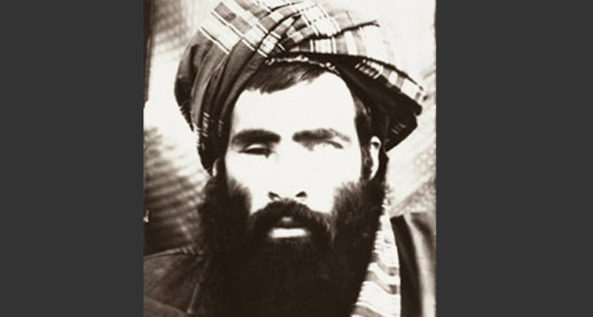
Why wouldn’t Mullah Omar talk? He has everything to gain.
Nothing could be clearer than the fact that there is an ever-widening divide in the perception, interests and understanding of the situation amongst the various stakeholders in Afghanistan. The regional states have their eyes on maximising benefits as the US reviews cutting its losses and bailing out of Kabul.
Although American officials explained that the Obama administration is yet to take a final decision regarding withdrawal of troops from Afghanistan, it is quite clear that the US and its Nato allies are looking for an exit. This would mean finding some face-saving method for allied forces to withdraw.
Regionally, attention is drawn towards Gen McChrystal’s recent remarks regarding negotiations with the Taliban. This is not a new idea but the conspiracy mill — which is forever productive in South Asia — has begun to talk about the possibility of the US doing a deal with the Taliban alone and leaving Afghanistan at the mercy of a Karzai-Mullah Omar coalition supported by India.
The Obama administration is considering various methods to woo the Taliban, that would include the use of money and carefully applying the divide and rule policy through which the ‘good’ Taliban could be separated from the ‘bad’. In this case, the good probably refers to a newer generation that might be more willing to cut deals with foreign forces than the older generation, which partnered with the likes of Osama bin Laden.
The anxiety expressed by some circles in Pakistan regarding a negotiation plan is strange considering that the military and the strategic community on the whole have always supported such an idea. In fact, Pervez Musharraf continues to market the idea. There is also the worry mentioned earlier that the US might do the talking on its own. However, this shouldn’t be a worry since it is not easy to ignore the ISI — with its extensive contacts with the Taliban. Sources even claim that a meeting between the ISI, CIA and Mullah Omar did take place in the past couple of months organised by Pakistan’s intelligence operatives.
The Taliban do not seem averse to talking to the US, especially now that Washington might not be insisting on Mullah Omar and his men surrendering Osama dead or alive. The Taliban and their handlers would be happy to negotiate with the US since they were never really averse to the idea of such talks. There are some who believe that an agreement could have been reached only if the US was not in such a hurry to attack.
Consequently, Mullah Omar seems to have signalled his willingness not to engage in a war in case he is included in Afghanistan’s future political set-up. Interestingly, other sources have denied the report. But why wouldn’t he talk as he has everything to gain?
Not only would he be a part of Kabul’s future political dispensation, he would also be a part of establishing a religion-oriented state that would get as much support from the West as Saudi Arabia, if not more. So denying reports of conciliation may be for harder bargaining but definitely not to create anxiety in western capitals which may force them to change their minds.
A deal with Mullah Omar is all that the allies could look forward to since there is no possibility whatsoever of a much-needed arrangement amongst regional stakeholders like India, Iran and Pakistan regarding Kabul’s future.
While Islamabad is apprehensive of the Indian presence due to its fear of a two-front situation in the future, India seems to be thinking in terms of the best- and worst-case scenarios. The former pertains to a situation where Delhi is able to put Pakistan on the defensive. It has already tried to achieve the objective through a mix of intelligence and development assistance tactics. The worst-case scenario for Delhi, on the other hand, pertains to the political balkanisation of Afghanistan in which Islamabad’s influence is limited to the southern provinces while India has greater influence over Kabul and the north.
There are apparent holes in this strategy since India might not be able to hold the south after an American withdrawal. Since Delhi has not invested in the friendlier provinces in the north and concentrated all its efforts in the south, it may not be able to establish a foothold in either part. It may try to do the trick through pumping money to the Afghan Taliban, but there are no guarantees that this will work.
There could even be a worst-case scenario in which Delhi gets crushed in Afghanistan and on its mainland through these non-state forces. The fact that Pakistan also bleeds profusely in the process is a given. But it’s sad to see states not understanding the future cost of their strategic games.
It’s most unfortunate that the regional states, which will suffer the most after they are left to confront each other’s interests in Afghanistan after a US withdrawal, do not think of a joint strategy. The Pandora’s box — which many believe was opened due to American intervention in Afghanistan — will not be shut by a US withdrawal. There are a couple of possibilities that come to mind.
First, there could be a deliberate lull in violence after the allied forces leave. This is a period when other regional forces with stakes in Afghanistan will be regrouping to claim greater territory and interests. Second, violence could probably increase initially in Afghanistan and then in the entire region.
The regional actors would pump in resources and use contacts with the proxies to create greater chaos and mayhem on the other side. This is certainly a dangerous proposition since what we may be looking at is a conflict which will not be contained within specific boundaries. Therefore, we may end up having larger ungovernable spaces. Such a development will threaten India as much as it will Pakistan. Or perhaps it will affect Pakistan more since society is already bleeding from the impact of a decade of the war on terror.
Sadly, there is no end in sight to proxy wars in the region and non-state actors. In fact, heightened competition between India and Pakistan over Afghanistan will result in greater justification on both sides for maintaining non-state actors as proxies.
Such a prognosis means that there will be more youth who will be deprived of their right to education, a better and hygienic environment, greater access to health and personal security. They will be sacrificed at the altar of national ego and fooled into ‘martyrdom’ in the name of faith.

