Talks with the Taliban
By Huma Yusuf
Monday, 01 Feb, 2010
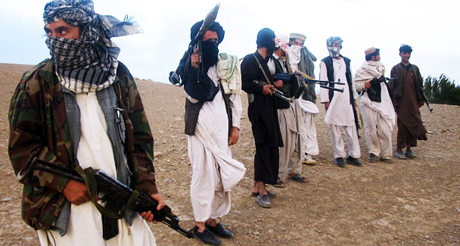
This file photo taken on Sep. 26, 2008 shows fighters with Afghanistan's Taliban militia standing on a hillside at Maydan Shahr in Wardak province. World powers supported President Karzai's plan to woo moderate Taliban fighters who disarm, as it emerged that senior figures in the militia held secret talks with UN officials.
In the matter of reintegrating Taliban fighters into Afghan society, the question is no longer whether to talk or not. President Hamid Karzai has already invited the Taliban to a peace jirga and UN representatives reportedly met members of the Quetta shura in Dubai to discuss the possibility of direct talks.
US Gen Stanley McChrystal even has access to a $1.5bn Peace and Reintegration Trust Fund to provide ‘incentives’ to militants to put down their arms. Thus, the question now should be whether or not talks can work.
Although the Dubai meeting remains unconfirmed, Karzai’s willingness to engage the Taliban leadership is bolstered by reports within Afghan diplomatic and military circles that certain militant commanders are tired of fighting and eager for a negotiated end to the conflict. The plan is to bring those Taliban who cut ties with Al Qaeda and abandon violence back into the social and political fold by offering security, vocational training, jobs and amnesty for past crimes.
It is unclear, however, whether Al Qaeda and those Taliban who do not seek amnesty will let this happen. In recent months, both the Afghan and Pakistani Taliban have killed anyone suspected of being an informer. And in Afghanistan, militant commanders who have surrendered to the government have been gunned down.
For talks to work, the Karzai administration will have to ensure security for militants who accept amnesty. This will not be an easy task given the fledgling ranks of the Afghan military and police (even if targets set in London this week are met by 2011, there will not be enough security forces to protect ‘reintegrated’ Taliban). It doesn’t help that hard-line Taliban factions have already infiltrated the Afghan security forces.
Until Karzai can promise security, talks could simply lead to more violence in the form of militant infighting. And if the International Security Assistance Force is required to help ensure security for reintegrated militants, the idea of talks may be stillborn since the Taliban have made it clear that their primary demand is the withdrawal of foreign troops from Afghan soil.
Assuming security can be guaranteed, the talks may yet stall owing to friction between Kabul and Washington. Currently, Karzai wants to reach out to all Taliban, including leaders such as Mullah Omar. The US, however, is in favour of engaging mid- and low-level militants, 70 per cent of whom are believed to fight for money and reasons other than ideological.
It seems unlikely that the US will wholeheartedly support reintegration efforts that grant amnesty to those high-ranking Taliban who sheltered and facilitated Osama bin Laden or worked closely with Al Qaeda. If Karzai insists on engaging the top Taliban leadership, Washington may reduce its involvement (in the form of billion-dollar funds) in the talks. In that event, negotiations will only work if the international community steps up to counter the shortfall. In London, world leaders pledged $1.4m to win over low-level militants. But far more will be required.
Regional stakeholders — each with their own agenda for protecting their national interests in Afghanistan — are also in a position to derail talks. Take Pakistan, for example. The fact that we have been left out of all secret talks between the Afghan government and Taliban through 2009 highlights the fact that our involvement could be a game-changer. Although it is accepted that negotiations with the Taliban cannot bear fruit without ISI involvement, the Afghan and US governments have indicated that they do not trust our intelligence agencies’ motives. There are concerns that the ISI will want to install those Taliban commanders with whom it has strong ties in the Afghan government, especially since the current administration is hostile towards Pakistan. If involved in negotiations, the ISI could tip the balance in favour of sympathetic Taliban commanders by offering better incentives. But as writer and journalist Ahmed Rashid points out, the Afghan Taliban are weary of being manipulated by the ISI. In the past few years they have become enmeshed with the anti-state Pakistani Taliban, grown closer to Afghan intelligence agencies and articulated their own ideological and political goals for Afghanistan.
Pakistan will want reintegrated Taliban to look out for Islamabad’s interests, discourage an Indian presence in Afghanistan to allay fears of encirclement, and reassure the Pakistan Army of the option of strategic depth. But in a role reversal, Pakistan may find that an Afghan government comprising former Taliban commanders is willing to provide safe havens for TTP militants and exert a potentially destabilising influence over Pakistan’s Pushto-speaking population.
If such divergent agendas are detected, Pakistan’s intelligence agencies could jeopardise talks. Negotiations can only succeed if all stakeholders, particularly Pakistan and India, prioritise regional stability over national agendas — this, unfortunately, is a long shot.
Finally, there’s the question of what demands the Taliban will bring to the negotiating table. In a November 2009 statement, Mullah Omar offered a vision of an Afghanistan free of ‘foreign invaders’ — there was no explicit mention of an Islamic state. But Pakistan’s experiences with the Tehrik-i-Taliban Pakistan in Fata and the Tehrik-i-Nifaz-i-Shariat-i-Mohammadi in Swat have revealed that extremist ideas of governance include a harsh interpretation and implementation of Sharia law. Afghan women’s rights activists are already balking at the suggestion of talking to the Taliban.
Until top Taliban commanders publicly welcome talks, there are too many unknowns to say whether reintegration can succeed. In the meantime, Pakistan should think through how best to balance its interests with Afghanistan’s future prospects, and prepare to let the Karzai administration take the lead.

