Mixed signals
By Huma Yusuf
Sunday, 21 Mar, 2010
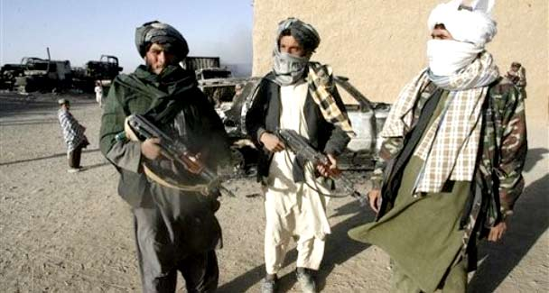
The disagreement between the UN and the US about the usefulness of the Taliban arrests points to different opinions about how America’s exit strategy from the region should be executed. — Photo by AP
The statement by Kai Eide, former United Nations special envoy to Afghanistan, indicating that the recent arrests of top Taliban commanders in Karachi had a “negative” effect has certainly irritated many Pakistanis. The sentiment is, after all, a direct contradiction of the United States mantra to “do more”.
As suicide and bomb attacks continue apace across Pakistan, these mixed signals from the international community — and our government’s reaction to them — make a mockery of the human and civic toll of terrorism in our country.
Eide’s complaint is that the arrests of Taliban second-in-command Mullah Baradar and other members of the Quetta shura have stalled efforts to find a political resolution to the war in Afghanistan. His contention is that the Pakistani authorities knowingly arrested key players in back channel negotiations.
The US has offered a swift rebuttal to this point of view, stating that Washington was “extremely gratified” by the arrests. Our foreign ministry, meanwhile, continues its tight-rope act, saying everything and nothing to keep everybody and nobody happy. Responding to Eide, a ministry spokesman asserted that the arrests were part of a joint operation with the US, and without addressing Eide’s accusation that “Pakistanis did not play the role they should have”, reiterated Islamabad’s support for a reconciliation process.
This jumble can be seen as a direct consequence of the Obama administration’s AfPak strategy announced a year ago. That strategy introduced three new dimensions: the announcement that US troops would leave Afghanistan by July 2011; the decision to treat Afghanistan and Pakistan as separate countries, with distinct interests, yet facing a common challenge; and the overly optimistic call for a regional approach balancing the interests of all stakeholders, including India, China, Russia and Iran. The repercussions of these are now starting to play out.
The disagreement between the UN and the US about the usefulness of the Taliban arrests points to different opinions about how America’s exit strategy from the region should be executed. The UN, United Kingdom, and European Union believe that a political settlement with the Afghan Taliban must be pursued alongside military goals, and that international bodies such as the UN should serve as neutral mediators. For this to work, talks need to start immediately.
The US, on the other hand, wants to focus on military operations and continue weakening the Taliban until they arrive at the negotiating table with heads hung low. As long as these different approaches vie for supremacy, Pakistan’s dealings with the Afghan Taliban will be variously perceived on the two sides of the Atlantic.
The long-term implications of the decision to treat Pakistan and Afghanistan as distinct entities, and to emphasise a coordinated regional strategy, are also starting to clamour for clarity. The fact is, until the various interests of stakeholders are made transparent and then systematically addressed, political games, power struggles and proxy battles will continue (at the time of Baradar’s arrest, many analysts speculated that Islamabad was indeed trying to hold the negotiations process hostage).
In recent weeks, the international community has become more honest about Pakistan’s stakes in Afghanistan. Earlier this month, Gen David Petraeus acknowledged that the Pakistan Army’s obsession with strategic depth is valid. And British Foreign Secretary David Miliband conceded that Pakistan “holds the keys” to security and dialogue in Afghanistan, and that Islamabad must be a partner in any solution to Afghanistan. For his part, during a recent visit to Islamabad, Afghan President Hamid Karzai stated that Pakistan should be involved in dialogue with the Taliban.
But a more upfront approach is needed so that mixed signals such as Eide’s critique do not become de rigueur — and the best place to start is with India. During his presidential campaign, Barack Obama talked about a resolution on Kashmir being the real solution to the Afghanistan problem. At that time, he was envisioning announcing an AfPak-India strategy in the event of being elected. That strategy acknowledged that Pakistan will continue to see militants as strategic assets and want influence over Kabul as long as an Indian threat is perceived on its eastern border. However, New Delhi’s rejection of any mediated dialogue on Kashmir forced Washington to change its tune, and it has left Islamabad and New Delhi to their own devices.
But the time has come to highlight India’s continuing impact on Obama’s AfPak strategy, not least because, in the wake of a US withdrawal, New Delhi — along with Tehran and Moscow, the traditional backers of the Northern Alliance — will see it as their responsibility to keep Afghanistan stable. It is Pakistan’s known concerns about this exact scenario that make its motives regarding Afghanistan dubious in the eyes of the international community.
Rather than continue to critique Pakistan’s actions — and distract it from addressing the spiralling threat of terrorism within its own borders — Washington and multilateral organisations such as the UN should address its concerns head on.
During the high-level strategic dialogue in Washington in the coming days, Pakistan plans to explain its concerns about Indian political and economic investment in Afghanistan. In turn, the US is expected to explain why it no longer sees India as a threat to Pakistan. One hopes this conversation is productive, and that it quickly leads to more concrete discussions about joint development projects in Afghanistan that reflect the interests of all stakeholders as well as a new emphasis on trade and transit that economically integrate Pakistan, Afghanistan and India.
huma.yusuf@gmail.com

