Challenges in Afghanistan
By Imtiaz Gul
Saturday, 06 Mar, 2010
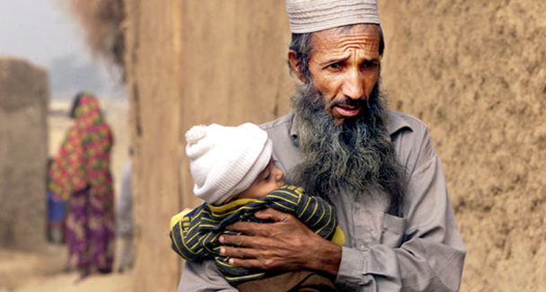
The majority of Afghans seem united in suspecting Pakistan of playing.

The well-planned assaults around the City Centre shopping complex and the Safi Landmark hotel in Kabul on Feb 26 delivered yet another blow to the Pakistan-Afghanistan-India confidence-building process.
This was the third attack on Indian interests — apparently — in Afghanistan during the past 20 months.
Condoling the deaths of nine Indians that included members of a medical team serving at the Indira Gandhi International Hospital, the Indian External Affairs Minister S.M. Krishna described the barbaric attacks as “the handiwork of those who are desperate to undermine the friendship between India and Afghanistan and do not wish to see a strong, democratic and pluralistic Afghanistan”.
In another veiled reference to Pakistan, he said: “The international community and the people of Afghanistan face a clear danger from the perpetrators of such acts of terrorism and their patrons.”
Most of Afghanistan’s state and private media also dropped direct and indirect hints about the ISI’s or ISI-backed groups’ involvement in the attacks that kept the capital in a state of shock for several hours. Clearly, the latest attacks will serve as yet another spoiler of any attempt aimed at improving bilateral relations.
The terrorist strikes on targets in the heart of Kabul will further cement the popular negative perceptions about Pakistan’s role in the region; from professors to politicians, students to state officials and from vendors to traders, the majority of Afghans seem united in suspecting Pakistan of playing a double-game. On the one hand, so runs the deep-seated perception, Pakistan is collecting billions of dollars from the West in the name of the anti-terror war, and on the other, it backs some of the terrorist groups that are hurting Afghanistan’s interests.
In a recent meeting with Pakistani academics and writers at his new office, Dr Rangeen Dafdar Spanta, Afghanistan’s ex-foreign minister who now heads the National Security Council (NSC), articulated these perceptions more vocally and directly: a) most Afghans think that all terrorist outfits and sanctuaries have official support, and b) Pakistanis believe the Indians are using Afghanistan (for terror acts in Pakistan).
He said that these perceptions were directly affecting Afghanistan, and until they are corrected through a bilateral or trilateral dialogue hopes for improving relations would remain elusive. He also reiterated that the Haqqani network, the Quetta shura and Hekmatyar remained Afghanistan’s primary concerns.
Dr Spanta and foreign ministry officials appreciate the current crackdown on the Afghan Taliban and were all praise for the recent arrests of Mullah Baradar and several others; yet they insist that Pakistan must stay the course. They also appear wary of “Pakistan’s paranoia about the Durand Line”. Dr Spanta played this down as “no main dispute” and advised that rather than stoking a controversial issue, Pakistani officials and civil society should concentrate on economic, parliamentary and intellectual cooperation and project their existing strengths.
Dr Spanta underlined cooperation and sustained dialogue among the intelligence and military establishments of both countries as the pre-requisite for better relations and the correction of perceptions. Discussions with diplomats and intellectuals also yield similar suggestions: they believe that Pakistan must project its soft power instead of indulging in controversial arguments. They point out that more than 52,000 Afghans cross the border both ways every day; the Pakistan embassy in Kabul issued over 200,000 visas in 2009 and the number is likely to cross 250,000 during the current year.
Meanwhile, at least 28,000 Afghan graduates currently occupy key positions in the government and the non-governmental sector of their country. A fair number of them studied in Pakistan. For instance, 26 people at the Asian Development Bank — which constitutes almost all the organization’s staff in Afghanistan — graduated from Pakistan.
A cursory survey by the Pakistani diplomatic mission suggests that almost two-thirds of the third echelon and above in the Afghan government — officials, advisors and ministers — have lived in Pakistan or continue to maintain homes in Pakistan. At the moment, some 6,000 Afghan students are studying at various Pakistani institutions.
At the same time Pakistan emerged, in 2009, as Afghanistan’s second-largest trading partner with the bilateral trade shooting up to $1.9bn, a 40 per cent increase from the previous year. Afghanistan, for instance, imported 8,000 tons of Pakistani cement daily during the summer, while the daily import in the winter months remained around 5,000 tons. Officials dealing with trading circles believe that the informal trade between the two countries hovers around $2bn.
Scores of Pakistani products available in the Afghan market, from packed milk and cream to water, sugar, edible oil, wheat flour and medicines also constitute living proof of the formal and informal trade between the two countries. And in terms of Afghan exports, about 50 per cent of its fresh and dry fruit lands in Pakistan — officially.
Meanwhile, as many as 60,000 Pakistani skilled workers and experts, from masons to IT and banking professionals, are currently busy in various sectors of the Afghan economy.

Unfortunately as the Afghans complain — and probably rightly so — leading Pakistani media institutions do not maintain even a regular, full-time stringer in Kabul. The only Pashto language channel, Khyber TV, does have a presence in Kabul and Jalalabad but only through stringers and lacks a regular office. Similarly, despite their exports to Afghanistan, Pakistani companies do not advertise for their sales’ promotion. And Afghans, traumatized by almost three decades of conflict, obviously take offence at these facts.
Civil society engagement and parliamentary contacts might mitigate mutual grievances, reduce antagonism and gradually transform militant, antagonistic behaviors into reconciliatory and cooperative dialogue between the people and governments of the two countries. Because of the mutual mistrust, non-partisan organizations such as Germany’s Konrad Adenauer Stiftung, which facilitated the delegation’s Kabul visit and plans to turn this into a regular mechanism, can also play a crucial role in this regard.
Afghans desire regional counter-terrorism strategies because the terror networks active in the region extend beyond national borders; while officials must pursue this, engagement in non-controversial areas such as education, trade and culture could help both countries in moving from their stated positions and mutual bickering.

