Why Karzai is fed up with the US mission
March 19, 2012 |

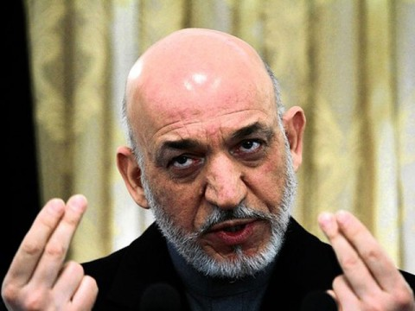
Joshua Partlow

For a decade, American troops have fought and died defending Afghan President Hamid Karzai’s government. On Thursday, with the US defence secretary looking on from Kabul, Karzai demanded that those troops stop fighting for him.
“Afghanistan is ready right now,” Karzai said in a statement, “to take all security responsibilities completely.”
With so much evidence to the contrary, it is tempting to assume that Karzai’s pronouncement is simply another provocation from a war-weary leader angered by American military lapses, the most recent of which was a US Army staff sergeant’s alleged shooting rampage that killed 16 Afghan civilians last weekend. Karzai said Friday that he is “at the end of the rope” over how the US military has handled the incident.
But he is not lashing out at the Americans - whose might and money seem so crucial to his survival - merely in frustration over his inability to control their conduct. The Afghan president’s reaction is rooted in his own evolution over nearly a decade of leading the country.
So what is he really thinking? When Karzai speaks, what should America hear?
Over the past month, I have talked with several of Karzai’s current and former aides about his views on the US presence in Afghanistan. They describe a president whose personality and political convictions have become fundamentally opposed to the American approach. His rhetoric is not simply a stunt for Afghan domestic consumption, or to show that he is no puppet president, as US officials sometimes suggest. It is a product of a deep-seated aversion to violence and an unshakable suspicion about US motives in Afghanistan.
For much of his second term, Karzai has been consistent in his belief that American troops are creating more problems than solutions in the war against the Taliban. The latest outrages - the viral video that apparently depicts Marines desecrating corpses, the burning the copies of holy Quran by US service members, the civilian casualties in Kandahar province - have reinforced his argument that the US counterinsurgency strategy is counterproductive. His demand that NATO forces stay out of Afghan villages and withdraw onto large bases follows a litany of earlier orders: the cessation of NATO airstrikes, Special Operations night raids and home searches; the abolishment of private security companies, NATO’s provincial reconstruction teams and American-run prisons.
The roots of Karzai’s views are as long as the war, but the confrontation with the United States intensified during his 2009 reelection campaign, a period one aide described as the “wound that never healed.” Palace officials say Karzai became convinced that the Obama administration actively sought to engineer his defeat. When he prevailed, they say, he saw the new American focus on fighting Afghan government corruption as another way to discredit him. If palace aides brought him advice that he considered too pro-American, they recalled, he sometimes dismissed it as the manipulations of the “yellow building,” as he called the US Embassy down the road.
“The president decided he would give the Americans a hard time, the way they had done to him,” said one former palace official. “In his mind, he did choose one, two, three, four important issues where he could press the Americans. And that was the civilian casualties, that was the detention centres, that was the private security companies and the night raids.”
Years before US officials acknowledged that the Taliban had found sanctuary across the border in Pakistan, Karzai and others in his government were convinced of this. The United States’ refusal to fight terrorism at its root there led many Afghan officials, including the president, to suspect that America must have ulterior motives, such as fomenting turmoil to justify a permanent military presence in the country, according to US officials who have worked with him.
Karzai has never been an enthusiastic commander in chief. He was sceptical of President Obama’s decision in December 2009 to send 30,000 additional troops to Afghanistan. Karzai aides describe his peace-loving temperament and say he has little interest in day-to-day military operations, sometimes cutting short his weekly national security council briefings on military updates in favour of discussions on geopolitics. At the palace, there is a long backlog of orders in death penalty cases awaiting his signature. He receives a document each afternoon outlining the number of insurgent, Afghan and coalition casualties, and “he hates that,” one former aide said. “His whole mind-set about this killing is very different than a general or a minister of defence. He doesn’t want to hear someone is killed, even a Talib. He thinks probably the Talib was an Afghan from an Afghan family. He’s by nature not into that.”
When asked in 2010 about his opinion of the American drone war in Pakistan, presumably the type of across-the-border military activity he might support, Karzai said in an interview with The Washington Post that his nature is “not one that appreciates military. I’m not a pro-gun person, I don’t like guns or airplanes, so I can never talk in favourable terms about planes that are shooting people or bombing people, so you’ll have to ask a more hard-core fellow. I’m a soft-core fellow.”
His day-to-day activities as president, which many have described as more akin to those of a tribal chief than a modern head of state, often involve meeting large groups of villagers and tribal elders who come to Kabul to air their grievances. The years of hearing stories of wrongful killing and imprisonment, stories that sometimes have brought him to tears, have also informed his thinking. “People come and complain, saying, ‘Americans are killing our children, and you’re responsible,’?” one current palace official said. “He’s caught between the international community and his people. And people are tired of accepting this.”
The United States has weathered many Karzai outbursts, and the crisis du jour often gives way to the status quo of a grudging partnership. But as powerless as many claim Karzai is, his demands have gradually won major political concessions, including an agreement to hand over the American-run prison at Bagram sooner than expected. He has also changed the landscape for foreign private security companies and instilled more caution in night raids and airstrikes.
Karzai does not appear to want a total US military withdrawal, but his staunch opposition to the current strategy could end up hastening that departure. Then his insistence that Afghanistan is ready to defend itself will be put to the test. –Washington Post
.

