Obama and Afghanistan
By A.G. Noorani
Saturday, 12 Dec, 2009
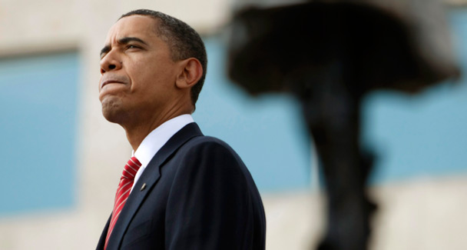
There is a fundamental flaw which affects the result of the best devised policymaking process.
Less than a week after President Barack Obama, made his long-awaited speech on Dec 1 on his policy on Afghanistan, his aides promptly put out word as to how elaborately he had conducted and concluded his policy review; the long agonising debates over which he presided and how ‘a young commander-in-chief set in motion a high-stakes gamble to turn around a losing war.’
The emphasis was on the withdrawal of troops, not on the induction of 30,000 men to add up to 100,000.
Only a fortnight earlier he had described Afghanistan as a ‘war of necessity.’ It was noticed that he did not use this expression again. To be sure a policy crafted after 250 hours of discussion has better chances of success than one hastily improvised.
It is equally true, however, that the sure instincts of a leader of sound judgment might sustain a policy he devises without much deliberation or even against all advice.
Obama lacks a sure grasp of international affairs. His advisers were divided. Lt Gen Karl Eikenberry, a retired commander of troops in Afghanistan and now US ambassador in Kabul, warned of trouble if more troops were included and warned also of outright civil war.
There is a fundamental flaw which affects the result of the best devised policymaking process. That is when the assessment of the situation is basically wrong and the policymakers are in a state of denial.
On March 27, 2009, two months after he was sworn in as president, Obama announced ‘a comprehensive new strategy for Afghanistan and Pakistan’ after, he claimed, ‘a careful policy review.’ He had already ordered the deployment of 17,000 troops. The objective was to ‘prepare Afghanistan to take responsibility for their security’ so that ‘we will be ultimately able to bring our own troops home.’
The strategy, such as it was, yielded no results. In the eight months that followed ‘the situation in Afghanistan has deteriorated’ as Obama acknowledged on Dec 1. The objective remains constant. An additional 30,000 troops will be sent but ‘after 18 months, our troops will begin to come home.’ It was a political exercise.
The president sought to please both the hawks and the doves. Neither were satisfied. It is impossible to shore up the Afghan army and security forces within that period.
A week later, on Dec 8, President Hamid Karzai told the visiting US Defence Secretary Robert Gates in explicit terms: ‘For 15 to 20 years, Afghanistan will not be able to sustain a force of that nature and capability with its own resources’ to thwart the opponents of the regime.
Assurances have flowed aplenty that the 18 months do not make a deadline for withdrawal. On Dec 7 the president’s national security adviser, Gen James L. Jones, asserted ‘we have strategic interests in South Asia, that should not be measured in terms of finite times. We’re going to be in the region for a long time.’
To what end? This brings us to the fundamental flaw and the state of denial which he shares with the American establishment. His identification of ‘the enemy’ is wrong. He equates the Taliban with Al Qaeda. He has also failed dismally to capture the mood of the people of Afghanistan. ‘Unlike Vietnam, we are not facing a broad-based popular insurgency.’
It is dangerous to base assessments on analogies. No two cases are identical. In Vietnam there was an organised insurgency. In Afghanistan there is deep alienation which fuels and sustains militancy.
Opinion can differ on whether it is possible to cut a deal with the Taliban and isolate the Al Qaeda. There can be no doubt as to the price which the Taliban will demand — a large, probably dominant, if not exclusive, power in Kabul and the departure from the scene of Karzai which, none will lament.
The Taliban have repeatedly spurned his overtures for talks; most recently on Dec 3. They will talk to the US but on the basis of withdrawal of foreign troops from the country. This Obama cannot concede with congressional elections only a year away. Probably not even thereafter for he will be up for re-election in 2012.
Unless, of course, the situation so deteriorates as to prompt the American public to demand the withdrawal of American troops. Even then opinion is certain to be divided. British opinion is also turning increasingly against the war.
One man stands out for his steadfast rejection of the myths on which his country’s policy is based. He is Graham E. Fuller, a former CIA station chief in Kabul and a former vice-chairman of the CIA’s National Intelligence Council. He wrote last week that the US troops are regarded as an occupying force, ‘an affront to Afghan nationalism.’ The war is not winnable and should not have been started in the first instance. ‘Strategic failure’ was inherent in the venture.
In his opinion ‘Pakistan will never be willing or able to solve Washington’s Afghanistan dilemma. Pakistan’s own stability has been brought to the brink by US demands that it solve America’s self-created problem in Afghanistan. Pakistan will eventually be forced to resolve Afghanistan itself — but only after the US has gone, and only by making a pact with Taliban forces both inside Afghanistan and in Pakistan itself. Washington will not accept that for now, but it will be forced to fairly soon.’
The United States supported and built up the jihadis, went away and let them capture power; and treated a terrorist attack as a war of aggression. ‘The Taliban inherited Osama bin Laden as a poison pill from the past when they came to power in 1996 and have learned a bitter lesson about what it means to lend state support to a prominent terrorist group.’
Even 250 hours of debate will not solve the problem unless the realities are faced courageously. That applies to us as much as it does to the US.

