No, 9/11 did not change the world
By Philip Stephens
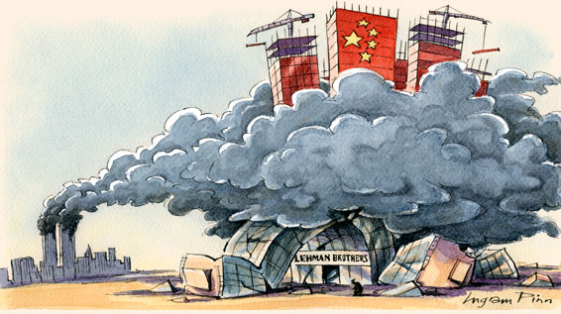
Just about everything has changed since the terrorist attacks on New York and Washington DC 10 years ago. The contours of the geopolitical and economic landscapes have been redrawn. The curious thing is how little the changes owe to 9/11.
This sounds counterintuitive after the tumult of the past decade. The US waged war in Afghanistan and Iraq. Violent Islamism transformed America’s view of the world, and the world’s view of America. Everything stood still for George W. Bush’s “war on terror” – or so it seemed. Al-Qaeda is still with us; so is Guantánamo.

More

On this story
- Philip Stephens Testing times for the west’s odd couple
- More from Philip Stephens
- Philip Stephens Spasm or spiral? The west’s choice
- Philip Stephens Working out what China wants
- Philip Stephens Rivalries among the rising rest
During a visit to Washington in the spring of 2003, I heard a senior US official explain how the invasion of Iraq would establish the new rules of the international game. Forget all that mush about multilateralism, this official told an audience of (mostly mushy) Europeans. This was the age of the single superpower. With or without allies, the US would avenge the felling of the twin towers. We were present, I wrote then, at the destruction of the multilateral order.
Yet for all the upheaval, it now turns out that the geopolitical forces shaping the present century will bear only slight connection to 9/11. Osama bin Laden grabbed a decade’s worth of headlines, but the future was being written in Beijing, Delhi, Rio and beyond. Two assumptions underpinned reactions to the first serious attack on the US mainland since the British sacked the White House in 1814. The first was that the US would assert the global primacy bestowed by victory in the cold war; the second, that the west’s security would be defined by a generation-long war against Islamist jihadis. Mr Bush’s administration soon added a third: the Middle East would be remade in the image of western liberal democracy.
Washington’s approach was codified in the National Security Strategy published in 2002. This promised permanent US hegemony, promulgated a doctrine of preventive war and cast aside the constraints of multilateralism. Never mind what anyone else thought. The US could act unilaterally.
The White House was far from alone in its assessment of US power. Shock and awe saw the media cast the US as a 21st century Rome. Commentators counted the carrier groups, stealth bombers and cruise missiles and declared America invincible – happily ignoring the vulnerability that had been exposed by al-Qaeda. Muammer Gaddafi was moved to surrender his weapons of mass destruction. Iran’s mullahs considered abandoning their nuclear ambitions and suing for peace.
The unipolar moment soon passed. Bin Laden is dead, and the US is leaving Iraq. Afghanistan is to be returned to the Afghans. The always curious notion of a “war on terror” has been quietly dropped. Islamist extremism is indisputably a serious threat – witness Pakistan, Yemen and Somalia. This is not, though, the Manichean struggle imagined by the likes of Britain’s Tony Blair.
The Middle East has indeed proved ripe for democracy, but not at the point of a cruise missile. Arabs are reclaiming their own future, careless of the views of US neoconservatives and of al-Qaeda alike.
Americans have tired of unilateralism and of preventive war. Barack Obama’s decision to lead from behind in the military campaign to oust Muammer Gaddafi fitted his country’s mood. When Republicans were recently offered a choice between preserving tax cuts and maintaining defence spending, they opted for the tax cuts.
American power is contested to a degree unimaginable after the fall of Baghdad. By any measure, the US remains the sole superpower, but few imagine it can any longer set the direction of global events on its own.
The world has indeed been turned upside down, but Afghanistan, Iraq and the badlands of Waziristan have been a smokescreen, obscuring the bigger story of the past decade. The changes that have mattered have been in the rising states of Asia and Latin America. Ten years on, the strategic challenge to the US comes from the rapid reallocation of power. The global order no longer belongs to the west.
The rise of the rest was long predicted. But no one thought it would happen so fast. Around the opening of the present century, the expectation was that China’s economy would match the US by, say, 2050. Now the expectation is that it will overtake it before 2020.
The challenge to the multilateral system established by Franklin D. Roosevelt and Harry Truman comes not from a unilateralist president in the White House, but from new great powers unwilling to accept an order designed by the west. This shifting balance owes something to perception – and anticipation – as well to hard realities. China may have just launched an aircraft carrier, but the US already has a dozen fleets patrolling the world’s oceans. For all that, the direction of travel counts: China is splashing out on its military just as the US retrenches.
The other big change, of course, flowed from the global financial crash of 2008. This was as much a geopolitical as an economic moment. The failure of the western banking system and the sovereign debt crises that stripped Europe of its remaining pretensions and the US of its triple A rating have shown us a world in which the west is no longer the master of globalisation.
The Washington consensus once set the rules for everyone else. Its liberal market capitalism was buried in the rubble of Lehman Brothers. China is America’s largest creditor. The rising states have their own economic models.
Mr Bush’s response to 9/11 reinforced these underlying trends. The wars in Iraq and Afghanistan have cost the US more than a $1,000bn in cash and just as much in global prestige. They have ended up showing the limits, rather than the reach, of military might. Cruise missiles do not work against improvised explosive devices.
What we are left with is a world betwixt and between. The sweep of history will record the past decade as a parenthesis – separating a brief period of unparalleled US might from a new, and chaotic, multipolar world. Al-Qaeda had to be defeated. But for all the horror he inflicted on 9/11, Bin Laden did not really change very much at all.
Copyright The Financial Times Limited 2011. You may share using our article tools.
Please don't cut articles from FT.com and redistribute by email or post to the web.

